SEHH2240 Group Project Group A07 CC-Store Online Platform

204A A07 Chen Wei Yui 24015277A 204A A07 Ting Ho Man 24176301A 204A A07 Shum YU Ching 24168915A 204C A07 Lu Chun Hei 24191330A 204A A07 Lin Rui Peng 24168294A

2025

Contents

[SEHH2240 Group Project Group A07 CC-Store Online Platform 0](https://studenthkccpolyuedu-my.sharepoint.com/personal/24015277a_common_cpce-polyu_edu_hk/Documents/2240.docx#_Toc195282854)

Introduction 3

Business Rule 4

Description of Business Rule 5

Logical design 8

Table: Customer 8

Table: Location 9

Table: *Payment* 9

Table: Products 10

Table: Category 10

Table: *Order* 11

Table: PRODUCT_ORDER 13

Relationship between tables: 14

Entity Relational Diagram 15

Login system 16

Queries design and Applications 17

BUTTON: CUSTOMER 18

TABLE: PAYMENT 18

TABLE: CUSTOMER 19

Query name: Customers Using Multiple Payment 21

Query name: Customers who paid 22

Query name: customer who unpaid 23

Query name: Dynamic VIP Query 24

Query name: find Customers with No Orders 26

Button:Order 27

Table:Product_order 28

Query name: ORDER 28

BUTTON:PRODUCT FORM 38

TABLE:CATAGORY 38

QUERY: MOST POPULAR PRODUCTS 39

BUTTON:FIND FORM 43

Query: Name Check 44

Query: Monthly Revenue Trend (2024-2025) 45

FORMS 46

FORM:LOGIN PAGE 46

FROMS:CUSTOMERS 49

FORMS:ORDER 54

FORMS:PRODUCT 59

FROMS: ALL PAYMENTMETHOD 65

FORMS:ORDER RECEIPTS 69

Implementation details 72

Software used: 72

Source of data: 73

Difficulties 73

Design phase: 73

Implementation phase: 73

Lessons learnt 73

Work distribution list 74

Conclusion 74

Reference 75

# Introduction

In this project, we chose a management system of B2C platform as the topic of our group, and we would like to create a management system for e-commerce platform that serves HKCC students online shopping service, which is named “CC-store”.

In this online shopping platform, we would like to create a database system to store the online shop records, we intend for our database system to include tables for location, customer, payment, order, products, category data and UserT. The location table will save data about where customers can receive products. The customer table will store the information of users who register on our website. The payment table will save the payment methods available for customers to choose. The order table will store information about the orders selected by customers. The product table will contain all the information about the products offered by the platform. The category table will be used to classify various products, then the UserT table will be stored the username and password of our Login system.

The whole system is designed to provide the control and maintenance for the online shop. All HKCC students would be covered in our online shopping platform.

In the database system, all data can be shown for the manager of “CC-store”. In order to mange the online shop more efficient, the system provides manger to query all data in the the online store. For the maintenance of the online shop, we design an interface for maintainer only. In this interface user is not only allowed to query data in the shop but also add or change the data. Realizing an efficient way for managing and maintaining the database system separately.

About customer, customer need to pick products they want into an order. After that the order would be saved into our database management system directly. The order contains data of customers, transaction detail, and products. Next, this platform provides serval payment ways for customers to choose. Finally, customers will go to different locations that randomly assigned by system to receive all the ordered products.

# Business Rule

About the **business rules** of our platform:

1. Table **Customer** and **Order**: Customer can have one or many orders, but each order is only given by one customer
2. Table **Order** and **Product**: each order can have one or many products, but each product can have one or many orders.
3. Table **Order** and **Location:** each location can get one or many orders, but each order only can contain one location
4. Table **Order** and **Payment:** each order only allows one payment, but each payment can allow one or many orders.
5. Table **Product** and **Category**: each product only belong to one category, but each category can be pertained to one or many products

# Description of Business Rule

***Each location can get one or many orders, but each order only can contain one location***

**Description**: Every order is associated with a specific location where the order is processed. This ensures that customers receive their products in an exact location and allows for better management of logistics. The “Address_ID” attribute in the Order table links each order to the location data which contains “Campus” and “Room”.

***Table Order and Payment: each order only allows one payment, but each payment can allow one or many orders.***

**Description:**

Each order allows only one payment transaction. This is tracked through a Payment table that includes details such as “PaymentStatus”, “TransactionID”, and “Payment_date”. While one order can have only one associated payment, each payment can cover multiple orders, providing flexibility in how customers settle their transactions.

***Customer can have one or many orders, but each order is only given by one customer***

**Description:** Customers can create accounts on our platform, which allows them to place one or many orders. Each order is exclusively linked to one customer, ensuring a personalized shopping experience. The customer profile includes essential details such as “Customer_ID”, “FirstName”, “LastName”, “email”, and “PhoneNumber”, enabling efficient communication and support.

***Each product only belongs to one category, but each category can be pertained to one or many products***

**Description:**

Each product belongs to a specific category, facilitating easier navigation for customers. The Category table contains attributes such as “category_code” and “type”, which help in organizing products into relevant groups. This structure allows customers to find products more easily and helps businesses manage their inventory effectively.

***Each order can have one or many products, but each product can have one or many orders.***

**Description:**

Each customer can add one or many products to their orders. The relationship between orders and products is managed through a dedicated table that tracks every product included in an order. This table will contain attributes like “Order_ID” and “Product_ID”, allowing for multiple products per order while ensuring that each product can appear in different orders.

# Logical design

## Table: Customer

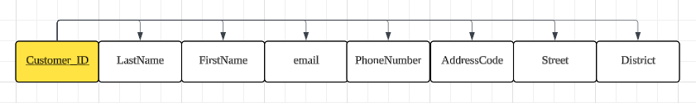

|  |  |  |
| --- | --- | --- |
| **Attribute** | **Data type** | **Rule** |
| Customer_ID | Short Text | PRIMARY KEY, NOT NULL,  UNIQUE |
| LastName | Short Text | NOT NULL |
| FirstName | Short Text | NOT NULL |
| Email | Short Text | NOT NULL |
| PhoneNumber | Short Text | NOT NULL |
| AssressNimber | Short Text | NOT NULL |
| Street | Short Text | NOT NULL |
| District | Short Text | NOT NULL |

## Table: Location

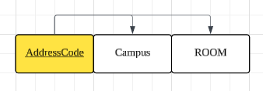

|  |  |  |
| --- | --- | --- |
| **Attribute** | **Data type** | **Rule** |
| AddressCode | Short Text | PRIMARY KEY,NOT NULL,UNIQUE |
| Campus | Short Text | NOT NULL |
| ROOM | Short Text | NOT NULL |

## Table: *Payment*

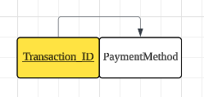

|  |  |  |
| --- | --- | --- |
| **Attribute** | **Data type** | **Rule** |
| Transaction_ID | Short Text | PRIMARY KEY NOT NULL  ,UNIQUE |
| PaymentMethod | Short Text | NOT NULL |

## Table: Products

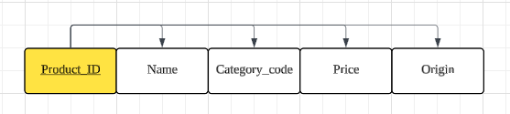

|  |  |  |
| --- | --- | --- |
| **Attribute** | **Data type** | **Rule** |
| Product_ID | Short Text | PRIMARY KEY, NOT NULL  ,UNIQUE |
| Name | Short Text | NOT NULL |
| Category_code | Short Text | NOT NULL, FOREIGN KEY REFERENCES TO CATEGORY TABLE |
| Price | Short Text | NOT NULL |
| Origin | Short Text | NOT NULL |

## Table: Category

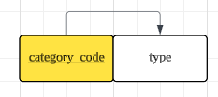

|  |  |  |
| --- | --- | --- |
| **Attribute** | **Data type** | **Rule** |
| category_code | Short Text | PRIMARY KEY,  NOT NULL  ,UNIQUE |
| type | Short Text | NOT NULL |

## Table: *Order*

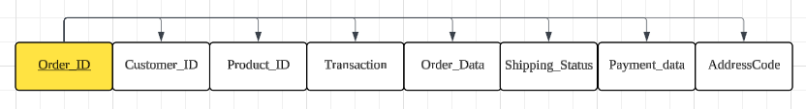

|  |  |  |
| --- | --- | --- |
| **Attribute** | **Data type** | **Rule** |
| Order_ID | Short Text | PRIMARY KEY, NOT NULL  , UNIQUE |
| Customer_ID | Short Text | NOT NULL, FOREIGN KEY REFERENCES TO CUSTOMER TABLE |
| Product_ID | Short Text | NOT NULL,  FOREIGN KEY REFERENCES TO PRODUCTS TABLE |
| Order_Date | Data/time | NOT NULL |
| Transaction_ID | Short Text | NOT NULL, FOREIGN KEY REFERENCES TO PAYMENT TABLE |
| Payment_date | Data/time | NOT NULL |
| Shipping_Status | Short Text | NOT NULL |
| Payment_Status | Short Text | NOT NULL |
| AddressCode | Short Text | NOT NULL, FOREIGN KEY REFERENCES TO LOCATION TABLE |

## Table: PRODUCT_ORDER

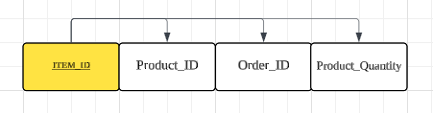

|  |  |  |
| --- | --- | --- |
| **Attribute** | **Data type** | **Rule** |
| Item_ID | Short Text | PRIMARY KEY, NOT NULL  ,UNIQUE |
| Product_ID | Short Text | NOT NULL, FOREIGN KEY REFERENCES TO PRODUCT TABLE |
| Order_ID | Short Text | NOT NULL, FOREIGN KEY REFERENCES TO ORDER TABLE |
| Product_Quantity | Short Text | NOT NULL |

## **Relationship between tables**:

The relationship between Customer table and Order table is 1: M.

The relationship between Location table and Order table is 1: M.

The relationship between Payment table and Order table is 1: M.

The relationship between PRODEUCT_ORDER and Order table is 1: M.

The relationship between Product table and PRODEUCT_ORDER table is 1: M.

The relationship between Category table and Product table is 1: M.

# Entity Relational Diagram

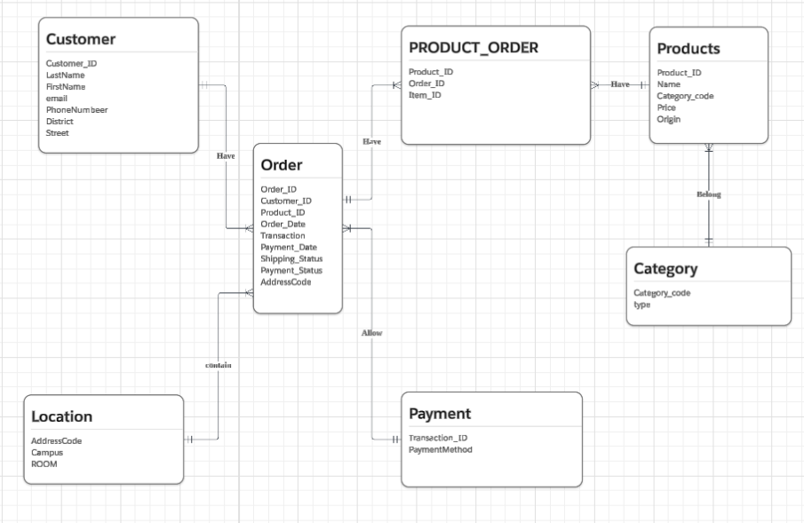

# Login system

The online shopping system provides an interface which is only for managers and designers. It allows all data can show to them.

The username with password is given below:

Maintainer, HKCC123

Enterpriser, HKCC456

# Queries design and Applications

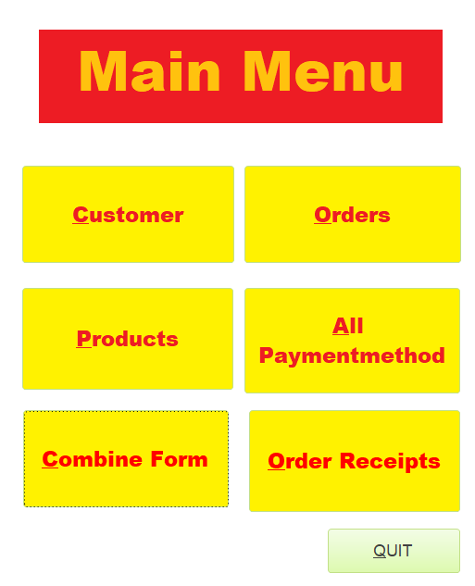

All Queries are used in Combine Form.

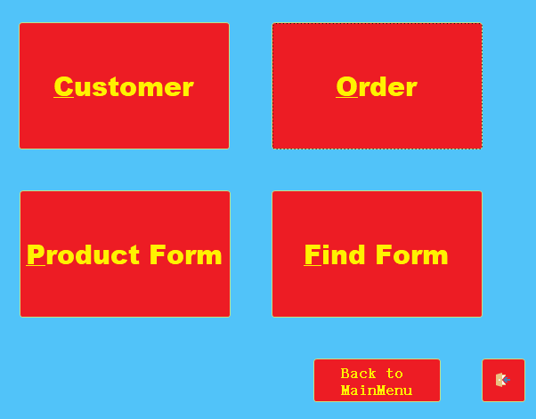

There have 4 different buttons for different Form.

## BUTTON: CUSTOMER

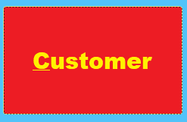

Those buttons will show table

in the Customer Form, their have those button, each button can show the table or run SQL

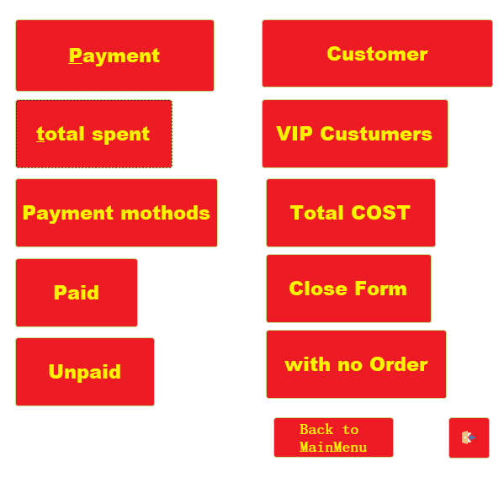

Back to MainMuen  
button

Those buttons will run Queries by SQL.

Back pag button

### TABLE: PAYMENT

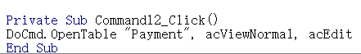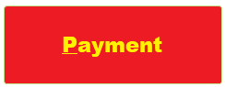

For showing Table, we use VBA code. Input DoCmd. OpenTable “Table name”, acViewNormal, acEdit.This is the prototype for showing table, that we can see the result like this↓

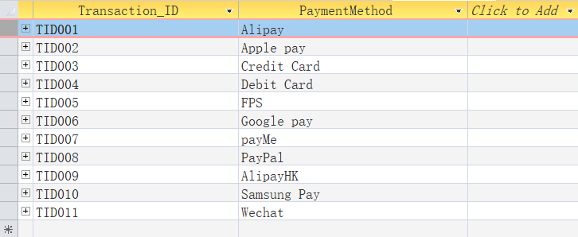

### TABLE: CUSTOMER

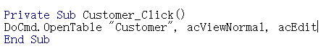

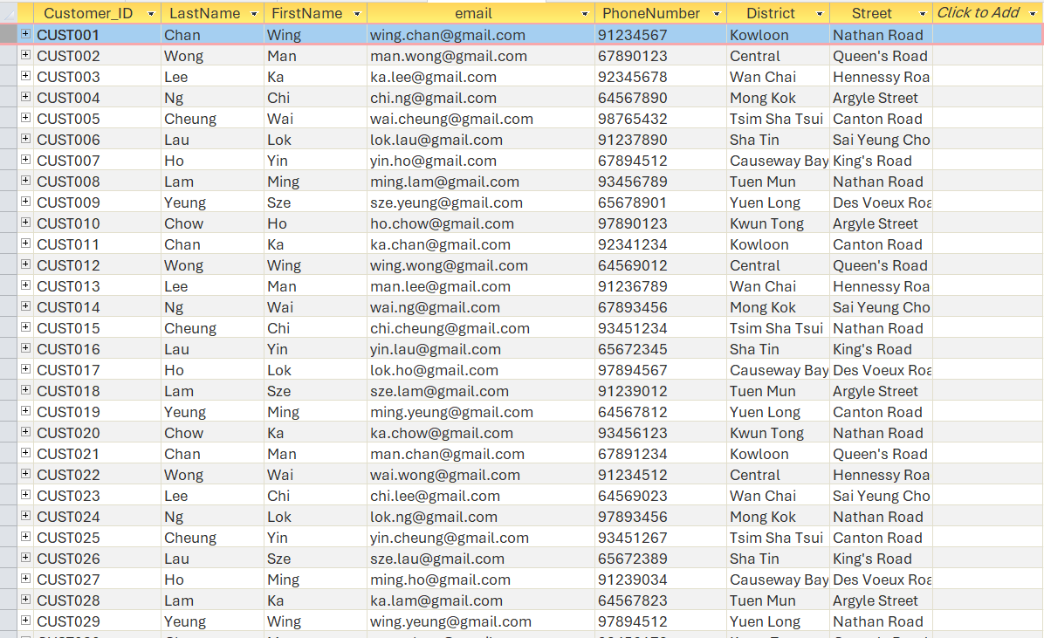

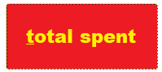 Query name: Customer total spent

When user clicks this button, it will Use Sum () function to calculate the total amount the users spend, store as a new attribute call “TotalSpent”. Only includes orders where Payment_Status="Yes". Excludes unpaid or pending orders from the analysis. Joins four tables to connect customer information with product pricing: Customer → Order → Product_Order → Products. This analysis could be used for Customer segmentation, marketing campaign prioritization in business application. Rank them from DESC, the result is shown like this↓

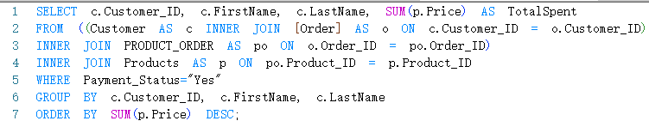

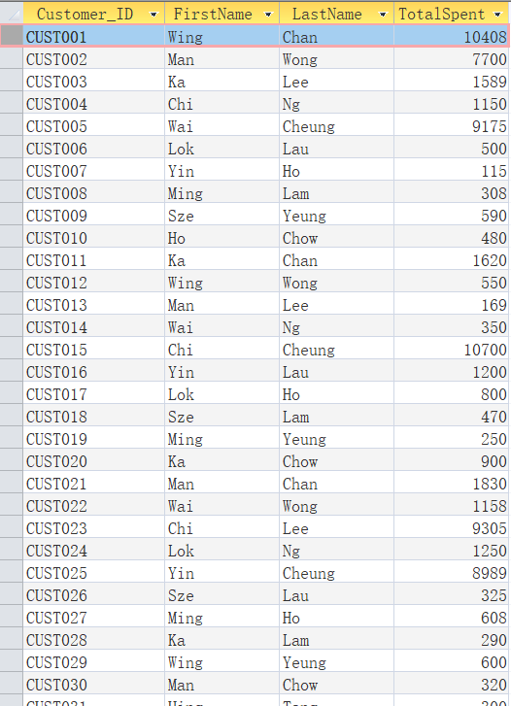

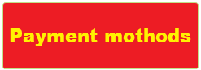

## Query name: Customers Using Multiple Payment

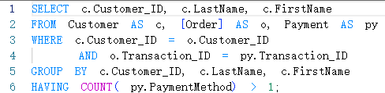

When user clicks this button, it will use Count () function to collect customer who had used more than one payment, Uses HAVING COUNT (py. PaymentMethod) > 1 to find customers use more than one payment. Connect 3 table (Customer → Order → Payment) to ensure accurate payment-to-order matching. This analysis could support Payment Strategy in business application. Then the result is shown like this↓

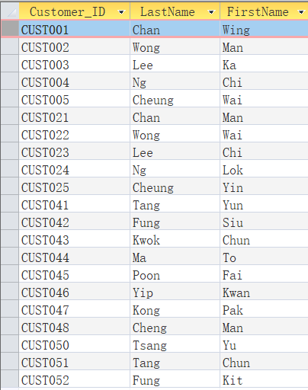

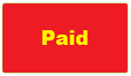

When user clicks this button, it will identify customers with outstanding payments by finding all orders where the payment status is marked as "Yes". Join Operator Style to inner join table Customer, Order, and Payment tables. Filters with WHERE (((Order.Payment. Status) = "Yes")) To collect which customer who pay already, how to pay, the Order_ID and the Transation_ID and customer information. It uses for Accounts Receivable Management**,** Customer Service... Then the result is shown like this↓

### Query name: Customers who paid



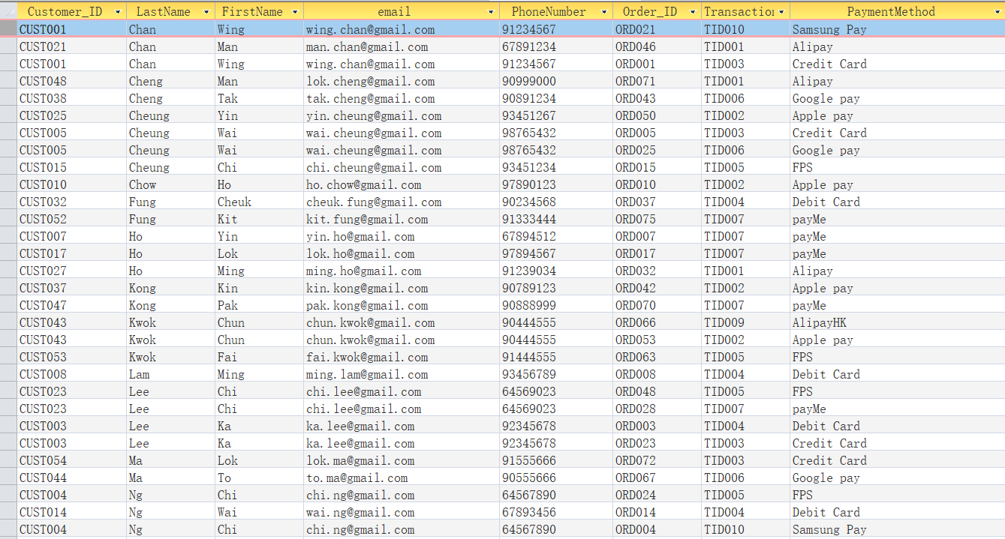

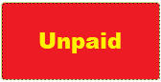

### Query name: customer who unpaid

When user clicks this button, it will identify customers with outstanding payments by finding all orders where the payment status is marked as "No". Join Operator Style to inner join table Customer, Order, and Payment tables. Filters with WHERE (((Order.Payment. Status) = "No")) To collect which customer who have not pay, the Order_ID and the Transation_ID and customer information. It uses for Accounts Receivable Management**,** Customer Service... Then the result is shown like this↓



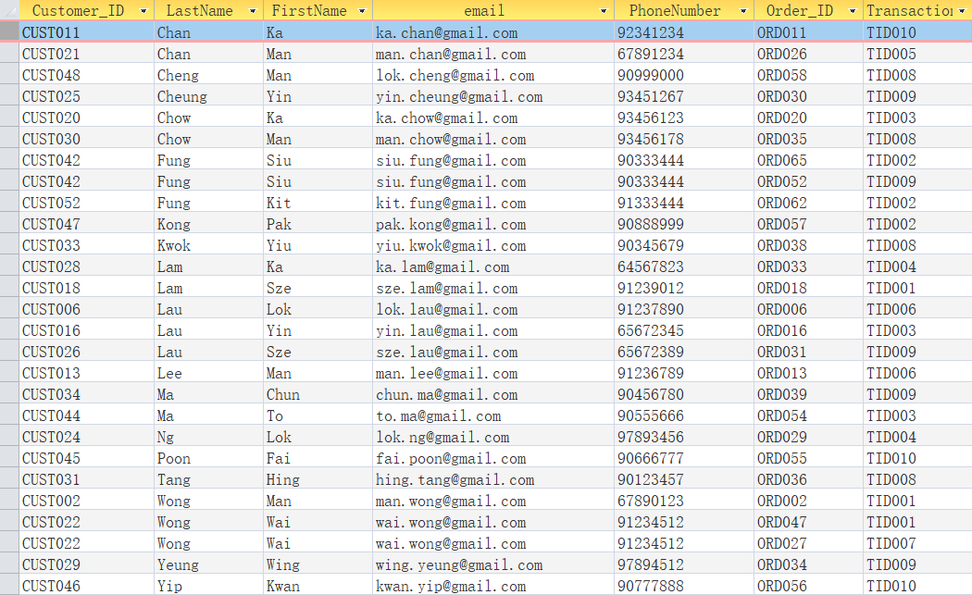



### Query name: Dynamic VIP Query

When user clicks this button, it will Use Sum () and IIF () function to calculate the Price, store as a new attribute call” TotalSpent” and “Status”, SUM(p.Price) AS TotalSpent to determine each customer's cumulative order data. Uses conditional logic: IIF(SUM(p. Price) > 3000, "VIP", "Regular") if Price>3000, then Status will store the data “VIP”. IF <3000, it will store “Regular”, INNER JOIN PRODUCT_ORDER (Customer → Order → Product_Order → Products), GROUP BY Customer_ID, FirstName and LastName then rankthem from DESC, it can use for Customer Segmentation Strategy. The result is shown like this↓

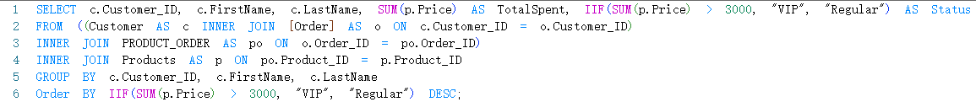

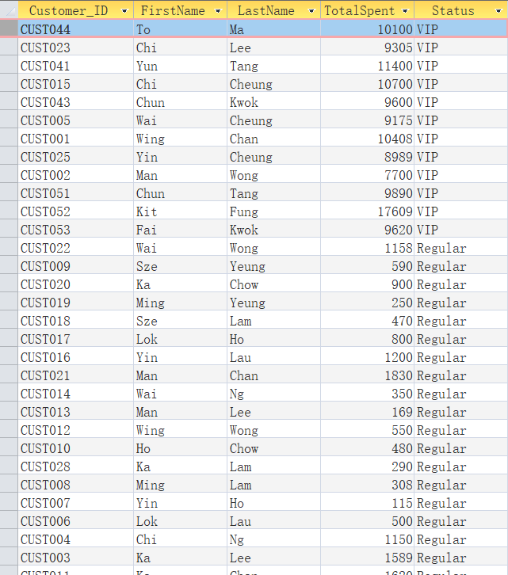

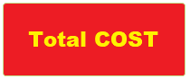Query name: Using Customer_ID to find Total Cost

When user clicks this button, the input box is shown, user needs to input Customer_ID, for example, CUST001, then the query will use SUM () function Sum(products.Price) AS Totalto calculate how much does the customer expenditure, analyze customer purchasing power by product to understand which customers purchased which products and how much they spent on the most products (Customer → Order → Product_Order → Products) Includes a placeholder like [] condition that could filter specific customers. Apply to Product performance analysis, inventory planning… The result is shown like this↓

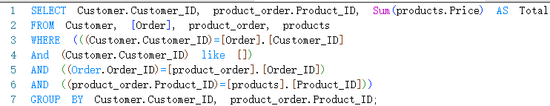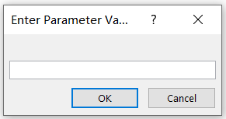

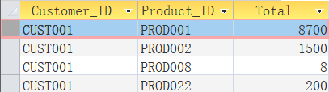

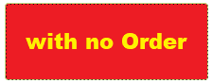

### Query name: find Customers with No Orders

When user clicks this button, it will collect which customer have not order. Uses LEFT JOIN to include all customers regardless of order history, WHERE o. Order_ID IS NULL filters to show customers without orders. Select customer information from customer and inner table Order. When order_ID is Null, it can for Customer Acquisition Analysis… The result is shown like this↓



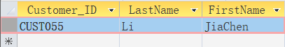

## Button:Order

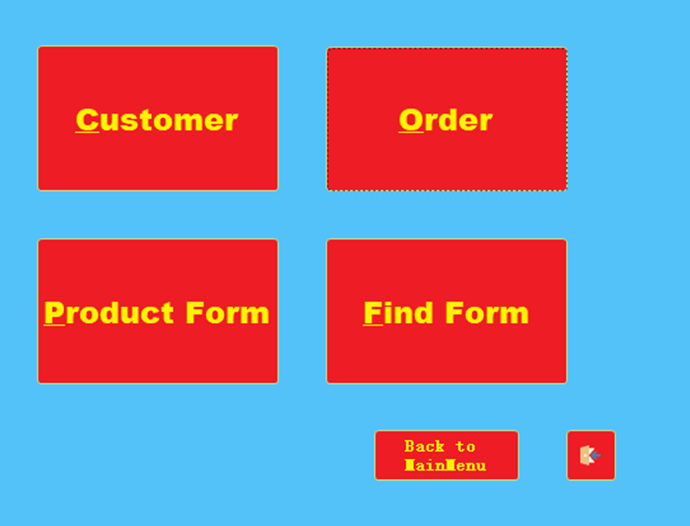

Order Form, it has those buttons.

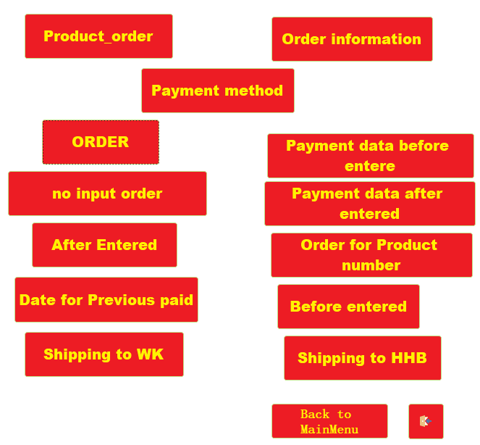

### Table:Product_order

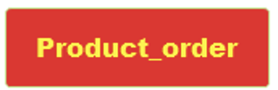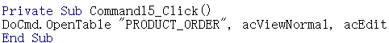

Here is the same VBA code to show the table PRODUCT_ORDER and Order.

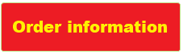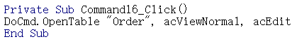

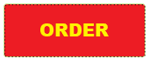

### Query name: ORDER

When user clicks this button, the SQL will joins six critical business tables (Customer → Order → Product_Order → Products → Category → Location) identity customer(SELECT *) to what they bought,Product classifications and Where items were shipped. it can use for customer be havior analysis, Customer can see which product is puplour. The result is shown like this↓

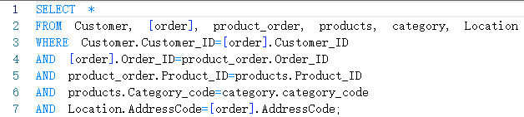

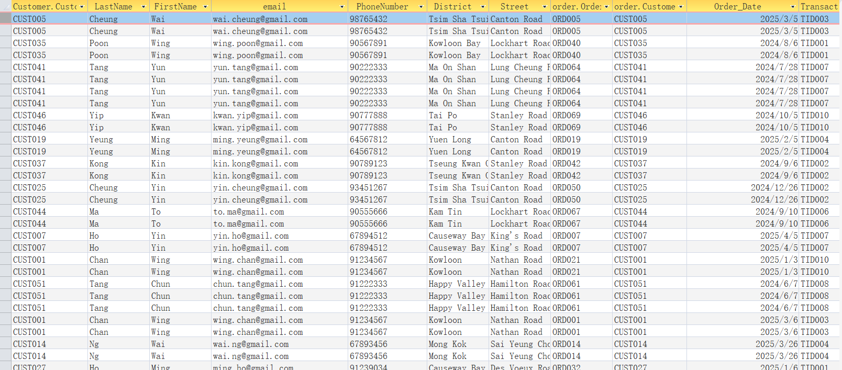

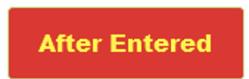Query name: find orders which after than you entered

Example:2025/1/1

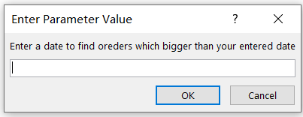

When user clicks this button, the SQL will identify customers who have made purchases after a specific date. ([Enter a date...]) is use of user to input the date. Sorts results by Order_Date DESC, it can use for customer engagement tracking. The result is shown like this↓

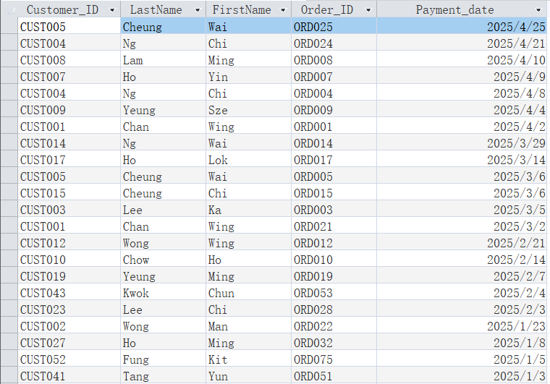

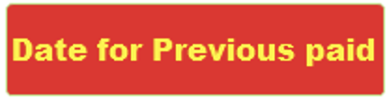Query name: Orders Paid with the Payment Method that you inputted

When user clicks this button, it will show two box let user to input the year and month ([Enter a year], [Enter a month]) to performs temporal analysis of orders by filtering for a specific month and year. It can use for Monthly Performance Analysis. The result is shown like this↓

Example:   
year=2025, month=1

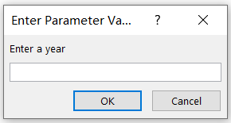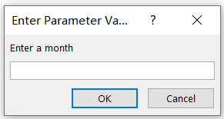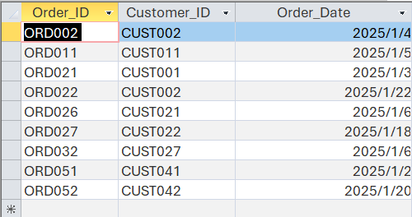

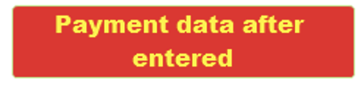 Query name: find orders which payment date after than you entered

When user clicks this button, it will identify customers who made payments after a specified cutoff date. Uses a dynamic date parameter ([Enter a date...]) to analyze payments after any chosen date. It can use for Accounts Receivable Analysis.The result is shown like this↓

Example: 2025/1/1

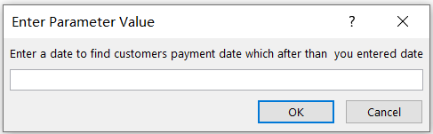

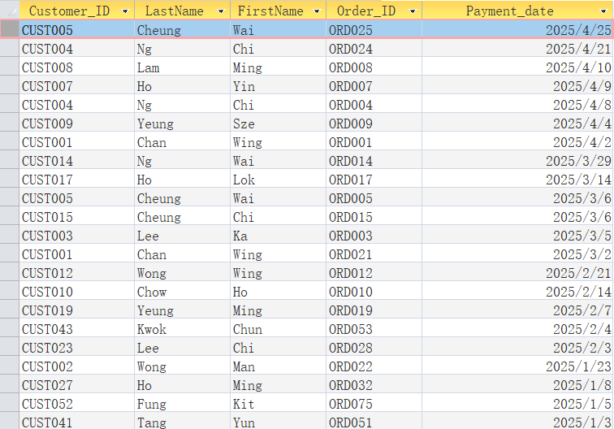

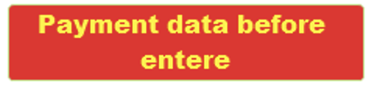 Query name: find orders which the payment before you entered

Example: 2025/1/1

When user clicks this button, it will identify customers who made payments before a specified cutoff date. Uses a dynamic date parameter ([Enter a date...]) to analyze payments after any chosen date. It can use for Accounts Receivable Analysis.The result is shown like this↓

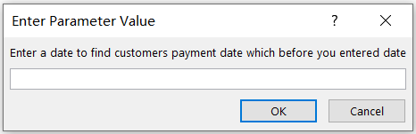

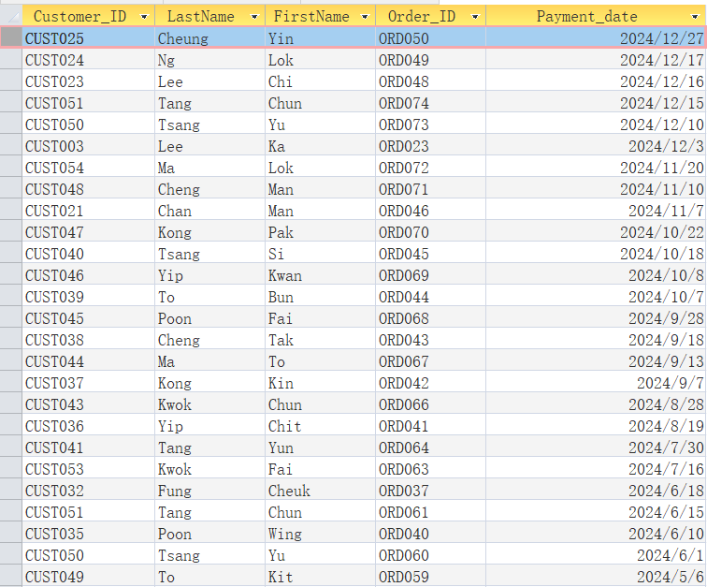

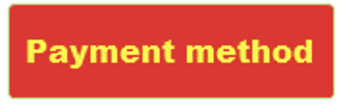 Query name: Orders Paid with the Payment Method that you inputted

When user clicks this button, User input a Payment Method [Enter a Payment Method], then SQL will Joins the Order and Payment tables via Transaction_ID. It will evaluate the effectiveness and adoption of a specific payment method. In Business Applications it can know Payment Channel Performance, Customer Experience Optimization… The result is shown like this↓

Example: Ailpay

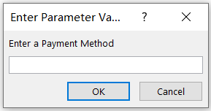

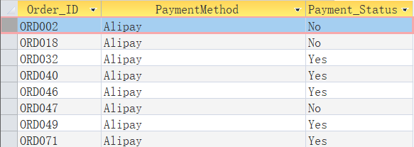

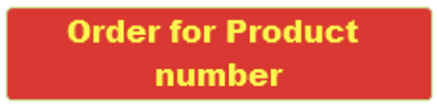Query name: Orders with Multiple Items

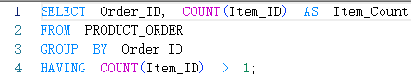

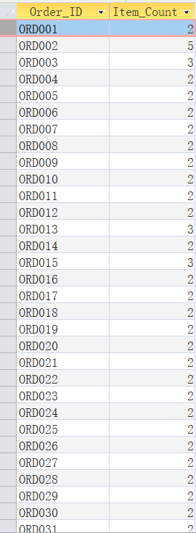

When user clicks this button, the query will **pinpoint orders with multiple items,** use Counts items per order (COUNT(Item_ID) AS Item_Count) and Groups results by Order_ID to maintain order-level context, Uses HAVING COUNT(Item_ID) > 1 to focus on orders > 2 data. It can use for sales strategy optimization. The result is shown like this.  
←

 Query name: find orders which the date before you entered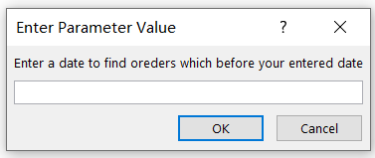

Example: 2025/1/1



When user clicks this button, when user clicks this button, the SQL will identify customers who have made purchases before a specific date. ([Enter a date...]) is use of user to input the date. Sorts results by Order_Date DESC, it can use for customer engagement tracking. The result is shown like this↓

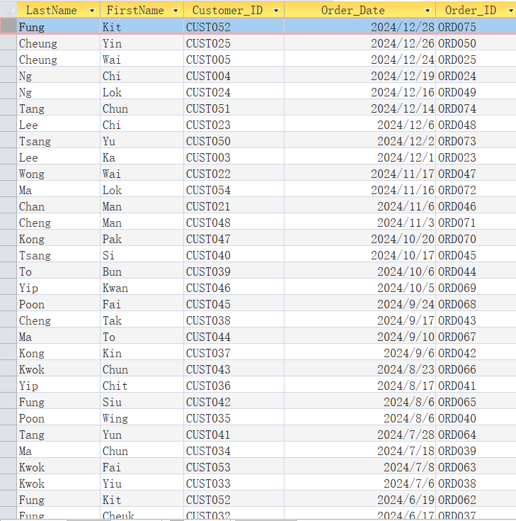

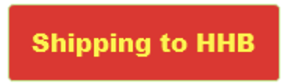Query name: Orders Shipped to HHB Campus



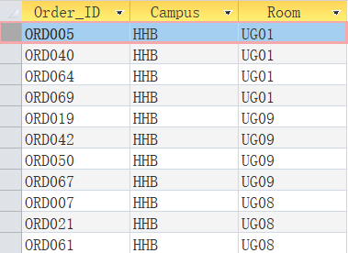

When user clicks this button, query will identify all orders linked to the HHB campus. After using the query Order_ID, Campus, and Room will be shown from Location table and Order table. All data is based on the location where is “HHB” (((l. Campus) =’HHB’)). In Business Applications, it can use for Operational efficiency. The result is shown like this↓

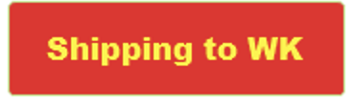Query name: Orders Shipped to WK Campus



When user clicks this button, when user clicks this button, query will identify all orders linked to the WK campus. After using the query Order_ID, Campus, and Room will be shown from Location table and Order table. All data is based on the location where is “WK” (((l. Campus) =’WK’)). In Business Applications, it can use for Operational efficiency. The result is shown like this↓

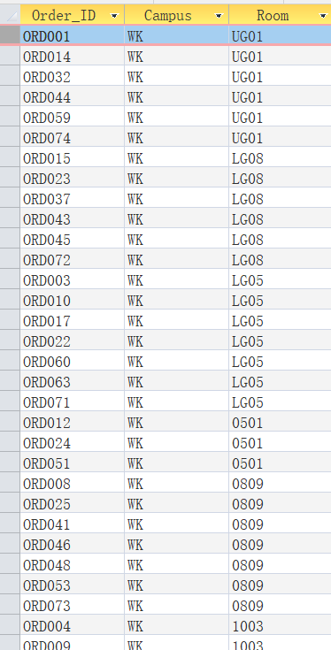

## BUTTON:PRODUCT FORM



This part demonstrates some records about Category and Product

We kick this button

Show Table Category and Product

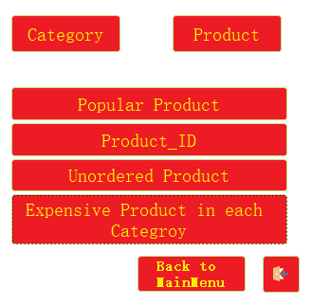

### A red rectangle with yellow text AI-generated content may be incorrect.TABLE:CATAGORY

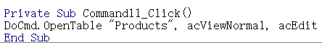

TABLE:PRODUCT

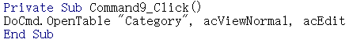

### QUERY: MOST POPULAR PRODUCTS

When click this button, will show records that most popular products in our platform



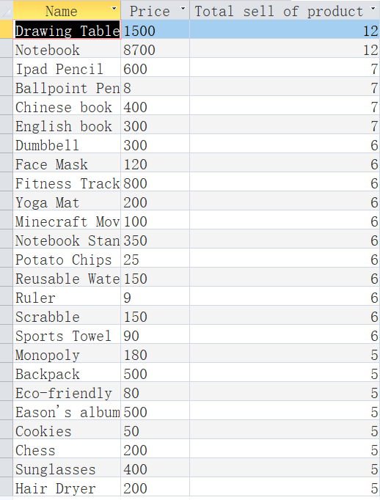

records

Show query

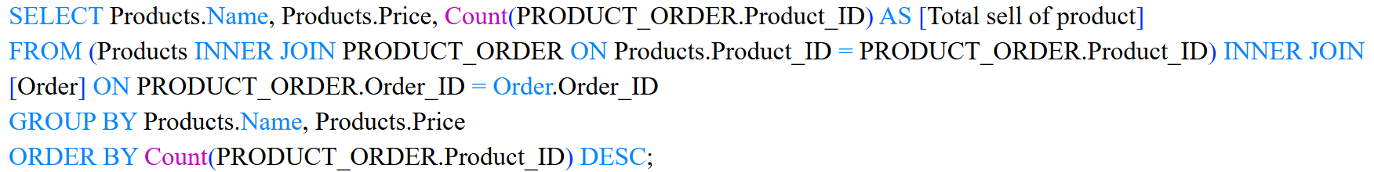

This SQL aim to count Product_ID to find records of the most popular products

Now, we show another button

Query: PRODUCT_ORDER Query

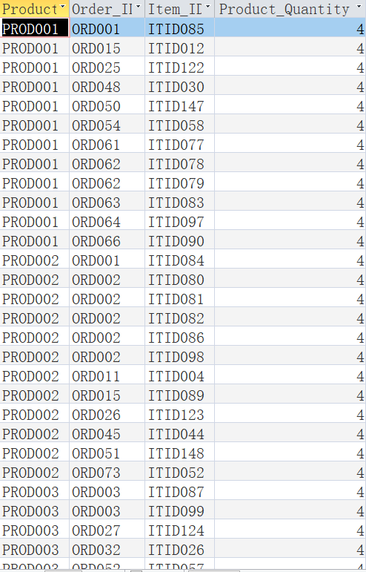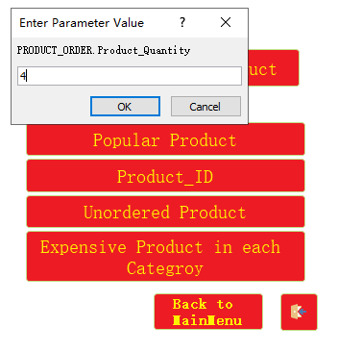

Enter a number

When clicking this button, enter a number then it will show record that order products numbers equal to input numbers, for example when I enter 4, it will show records which having 4 products orders.



Enter a number

This SQL aims to let you enter a number to find orders which equal to your entered number.

Query: Products Never Ordered

Then to the query:Unordered product

When clicking this button, it will show records of products which are not ordered

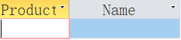

Because not have any product not be ordered, therefore it shows a null result



This SQL find Product_ID in table order is null or not null, to find products which are not ordered

Then to the query:

**Expensive Product in each Category**

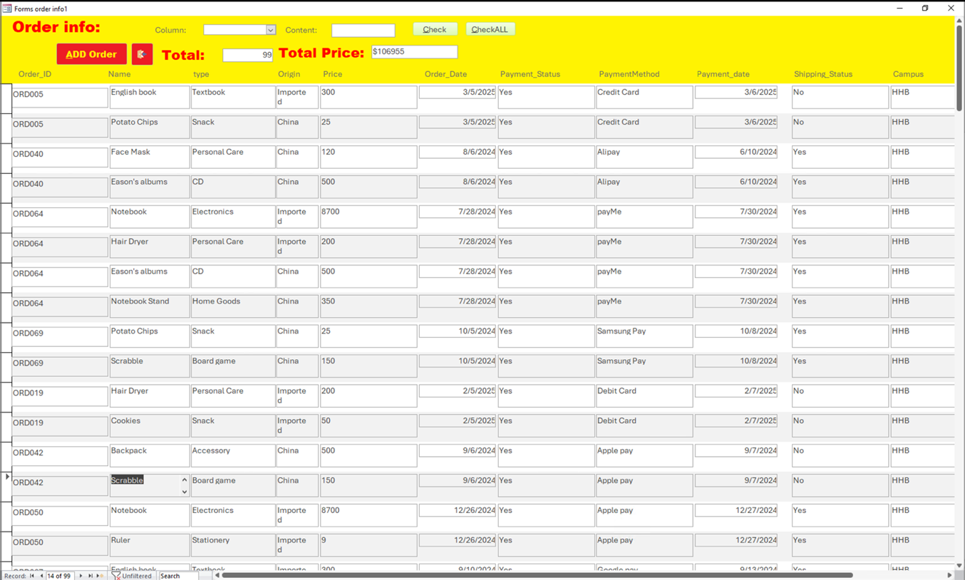

Query: Most Expensive Product in Each Category

When click this button

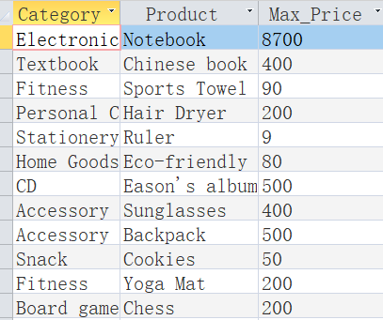

The table show that each category most expensive product

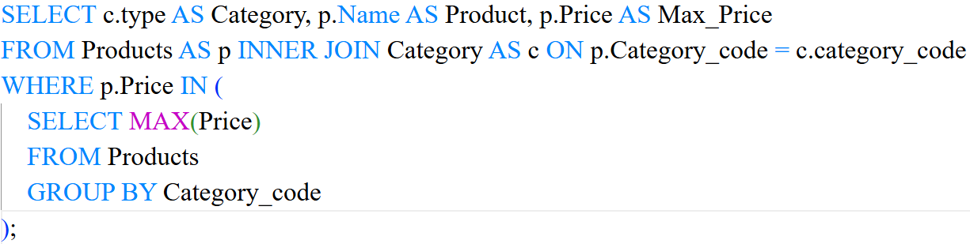

This SQL use MAX operator to find max price of product of each category

## BUTTON:FIND FORM

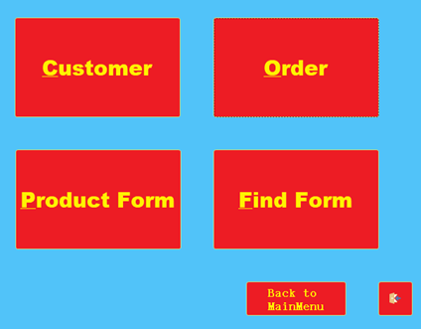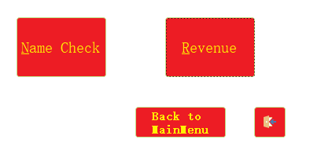

we can see that there has two buttons

Then to the next part Find Form

First about the Name Check Button

### Query: Name Check

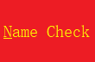

When click this button, it will require you to enter Customers FirstName and LastName to find their information

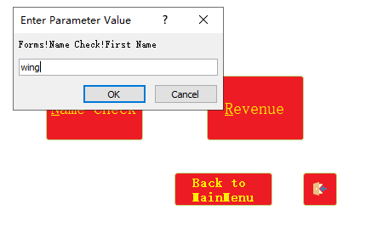

First, we enter Customer First Name, for example I entered “Wing”

First, we enter Customer First Name, for example I entered “Wing”

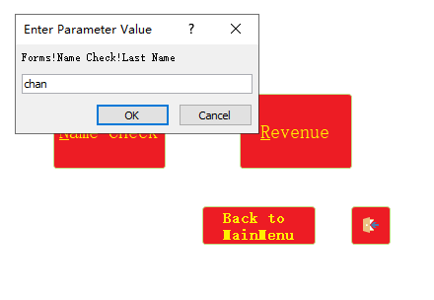

then, Enter Customer Last Name, for example “Chan”

then, enter Customer Last Name, for example “Chan”



Showed “Chan Wing” information

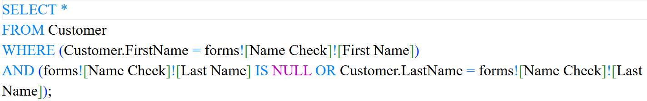

The SQL use [] function to find information of Inputted FirstName and LastName

### Query: Monthly Revenue Trend (2024-2025)

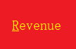

Then about the Revenue Button,

when click this button

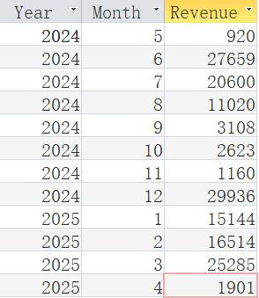

The table show the Monthly Revenue Trend of 2024-2025

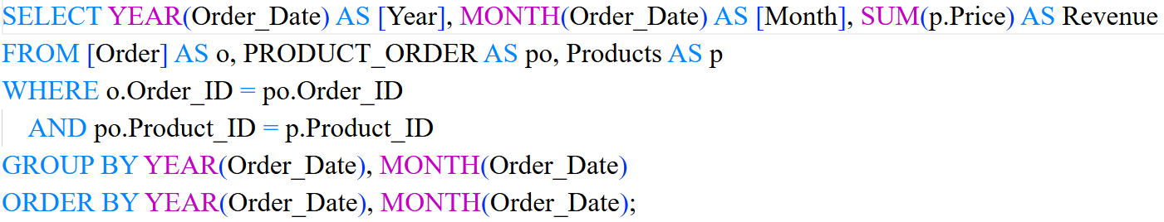

By using SUM() , Group by and Order by function to calculate 2024-2025 Monthly Revenue Trend of Online Shop

# FORMS

## FORM:LOGIN PAGE

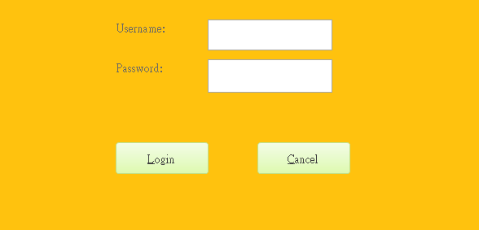

We have two account Maintainer and Enterpriser, Maintainer can change and add the data .but Enterpriser can only access the data, and they cannot make a change.

We have make change in this code

Customer change to Enterpriser

Designer change to maintainer

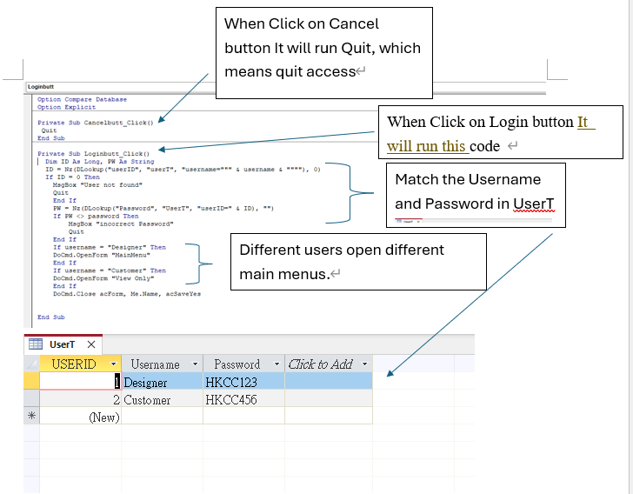

Maintainer

Enterpriser

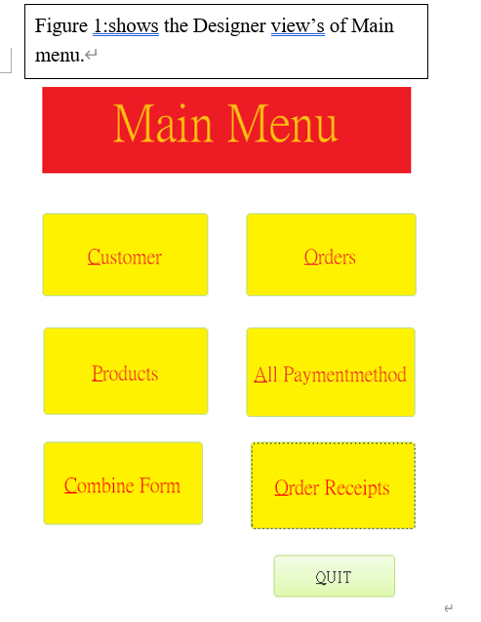

Figure 1:shows the Maintainer’s view of main menu

They are almost same ,It is different in four button which are Customers, orders ,products and All patmentmethod. clicking the on will open the new form.

Figure 2:shows the Enterpriser’s view of main menu

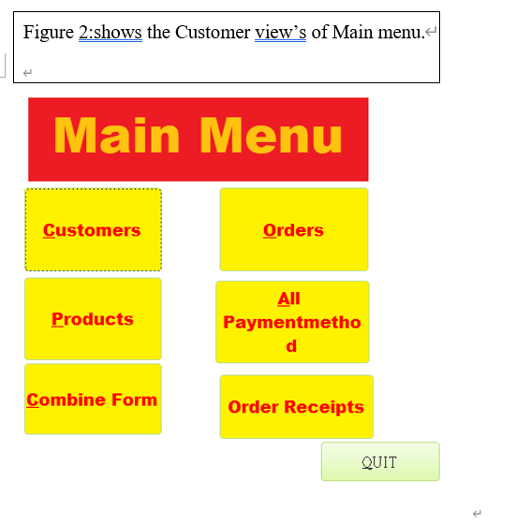

Those four button’s interfaces are the same. But Maintainer view will have the button for added data lick the first attribute open a form to change or delete the data.

## FROMS:CUSTOMERS

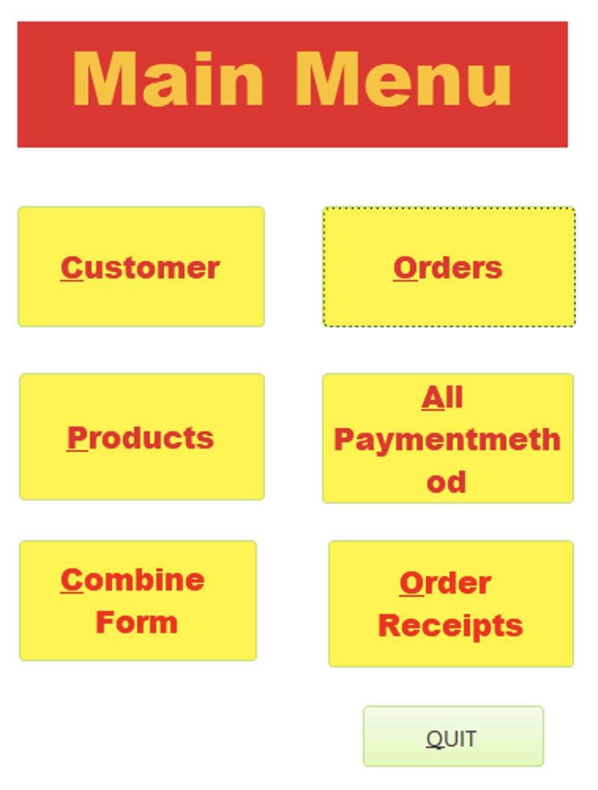

Button Order, Products and All Paymentmethod have same functions, including adding data, changing, deleting and conducting query.

Kick this button

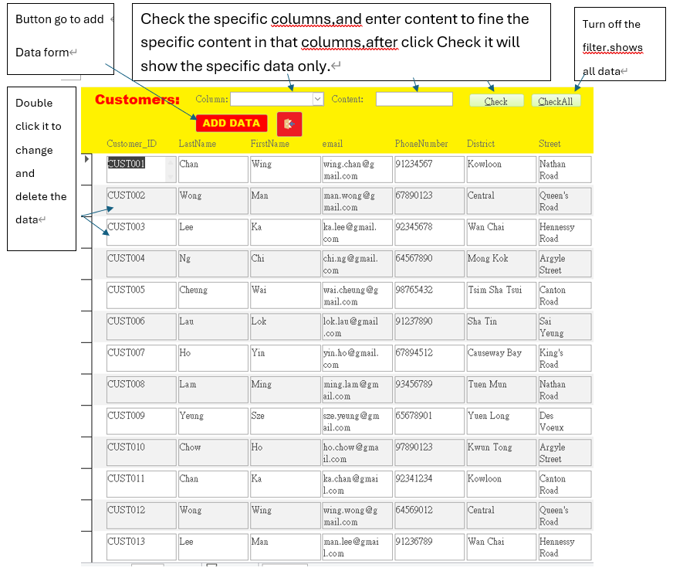

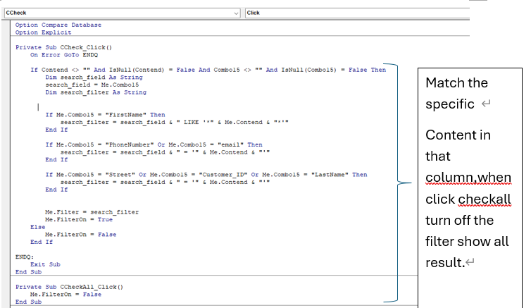

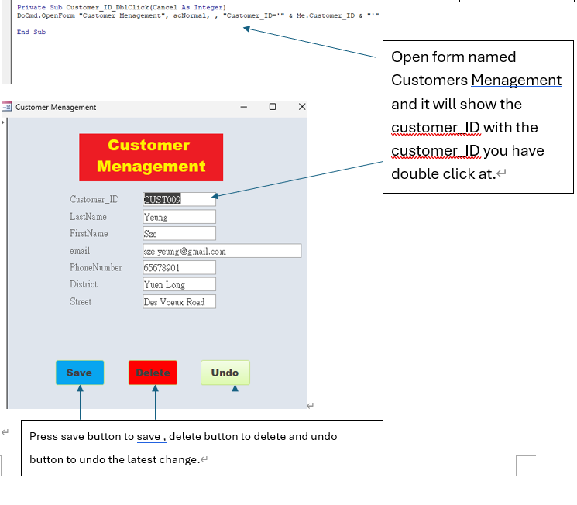

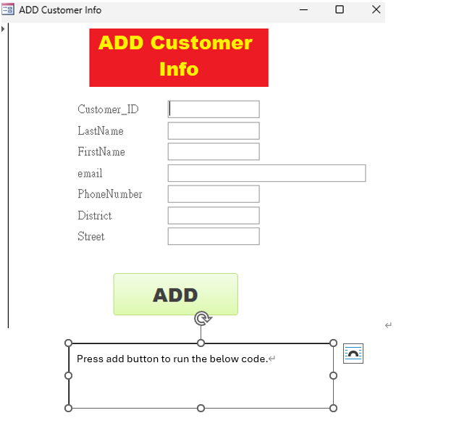

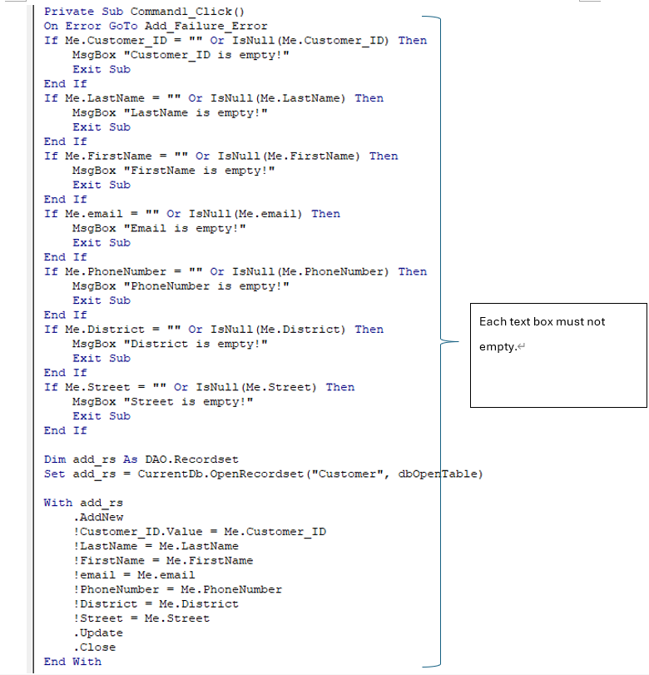

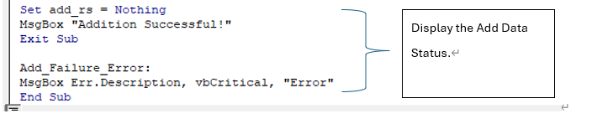

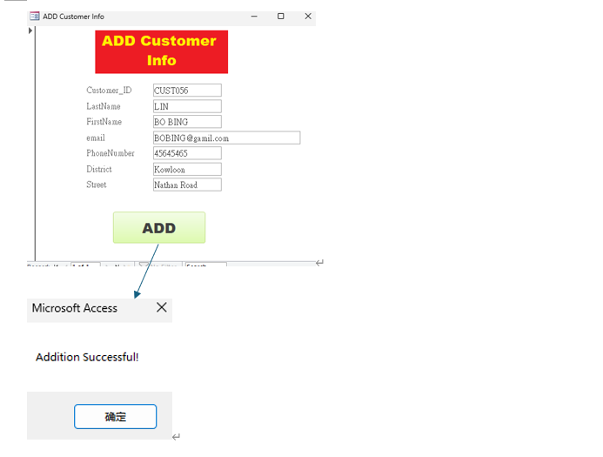

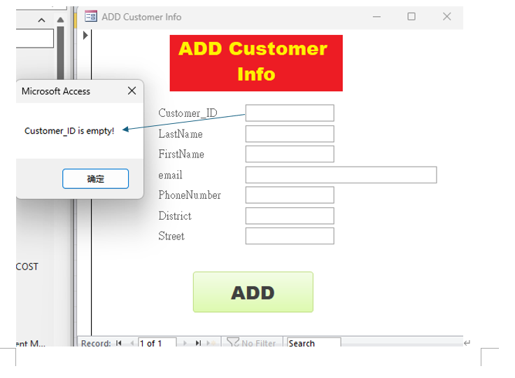

## FORMS:ORDER



Click this button

Same Function with customer form .

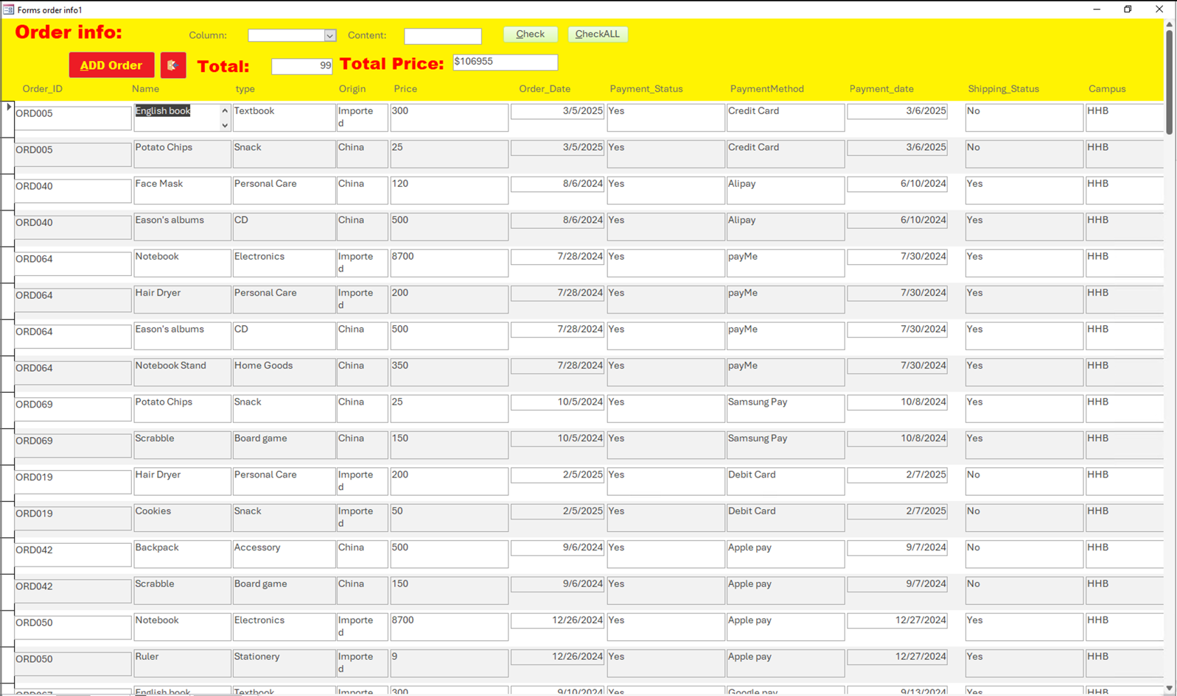

Using function to show the Total .using =”$”& to show a $.

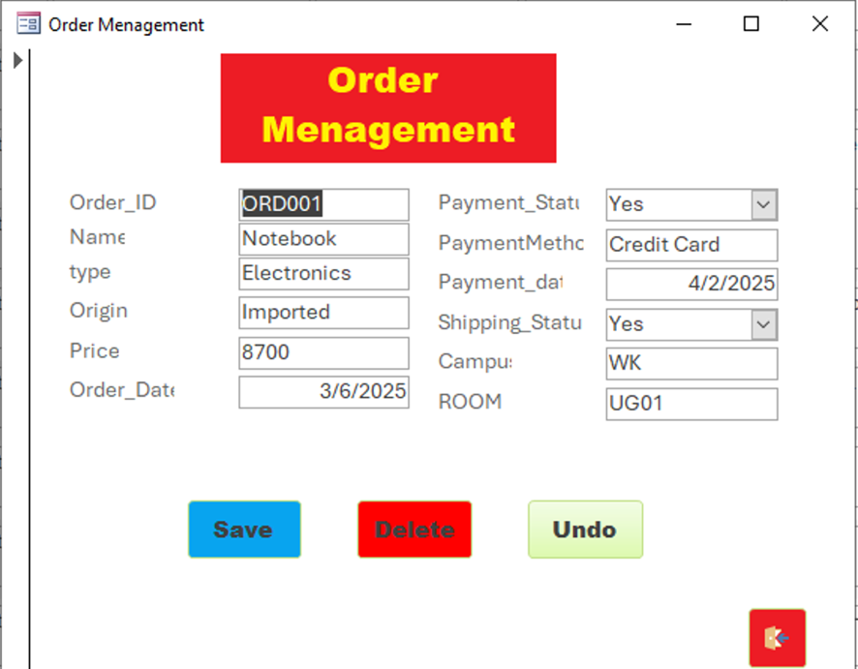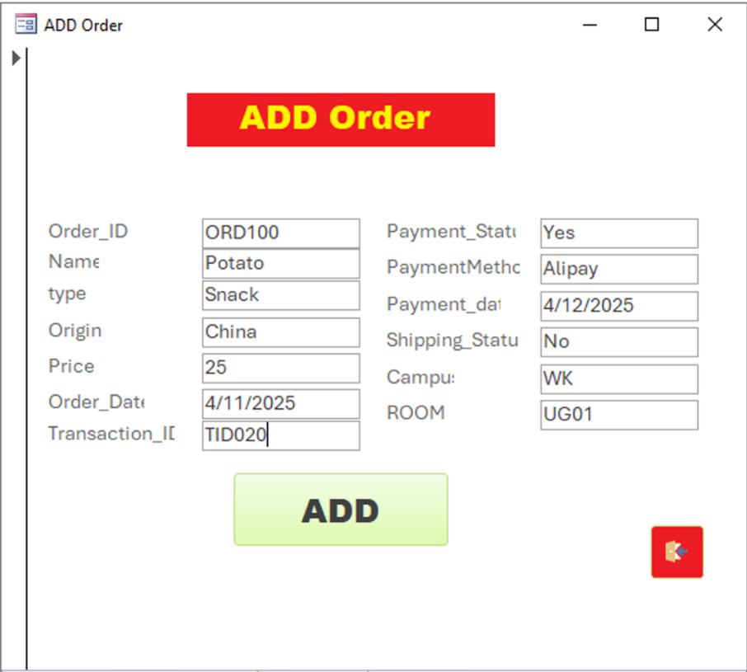

A form that can add the order data

A form that can change and delete the order data.

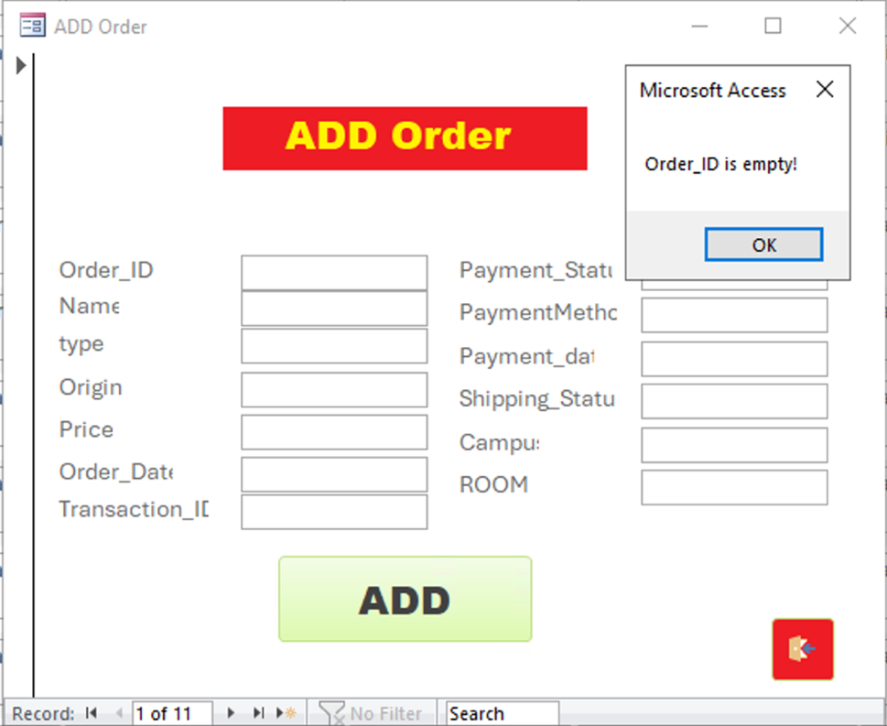

Empty input will show a MsgBox tell you where is empty.Empty input will show a MsgBox tell you where is empty.Empty input will show a MsgBox tell you where is empty.

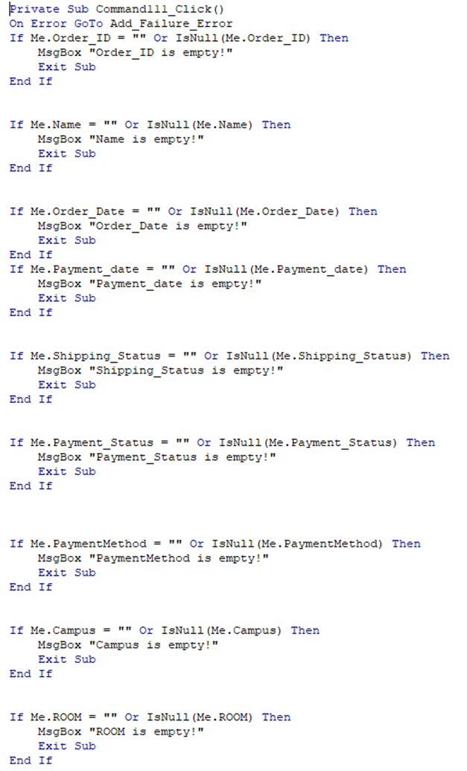

Code for add order form.same functions with customers.

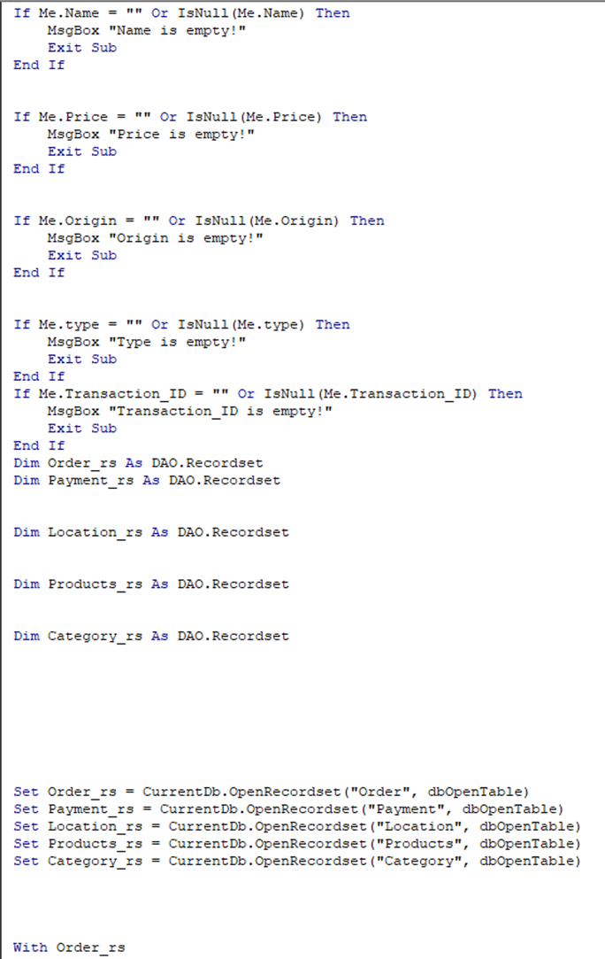

Code for add order form.same functions with customers.

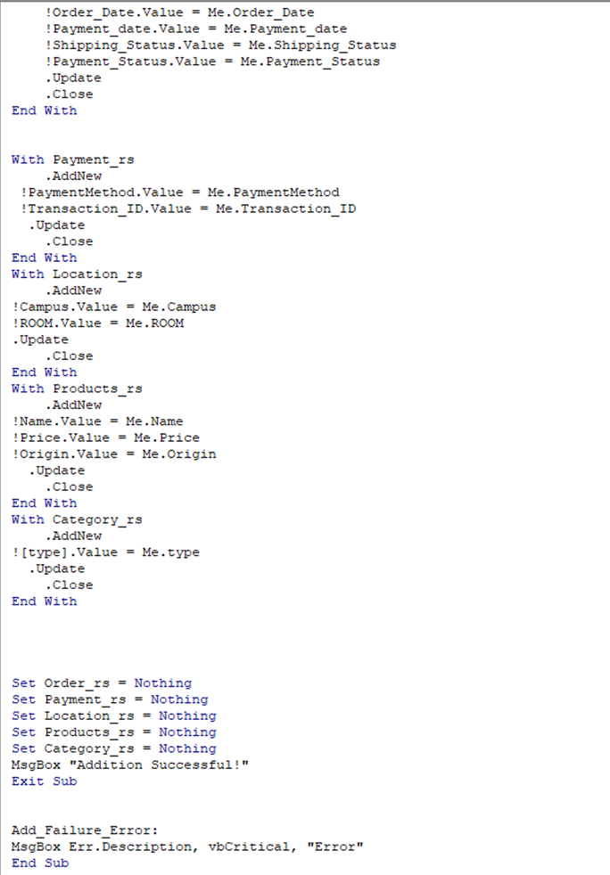

## FORMS:PRODUCT



Cick this button

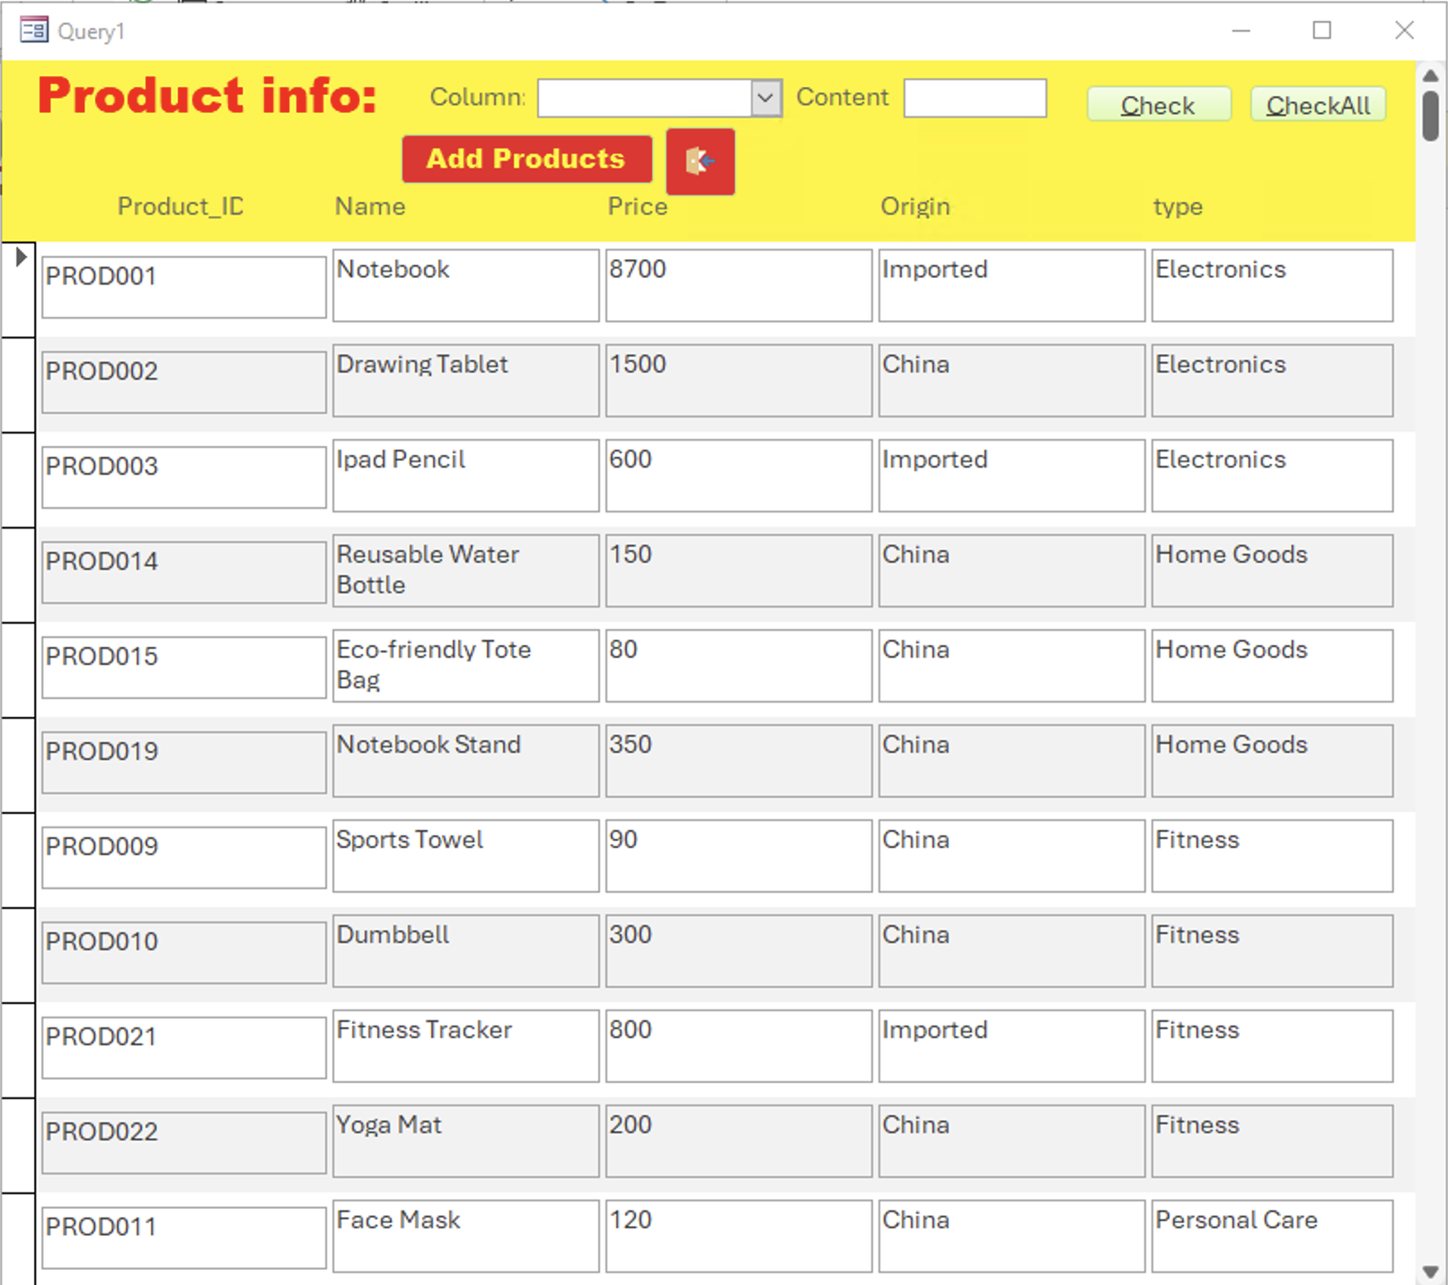

Samr function with customer Forms.

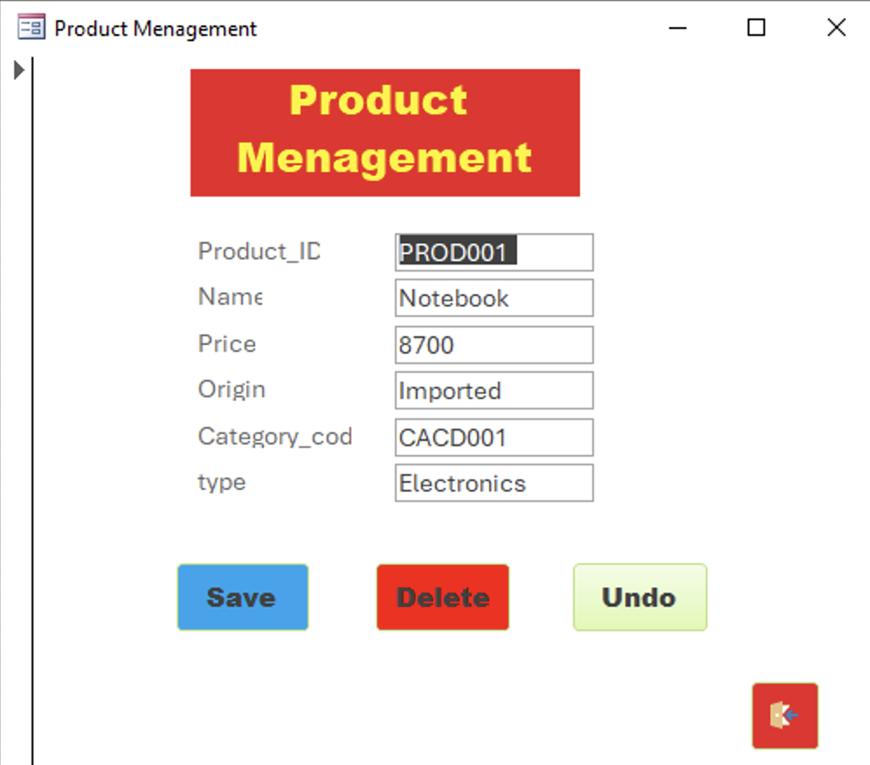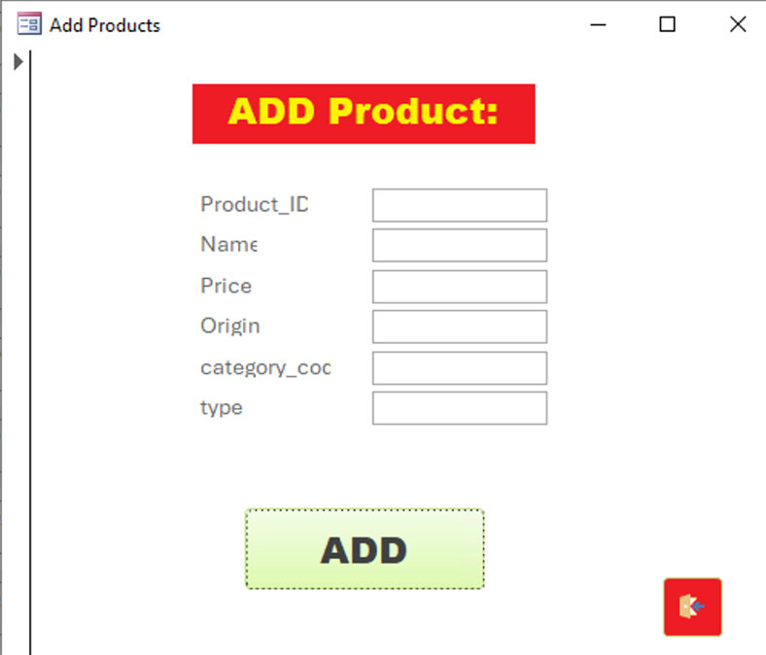

A form that can add the product data.

A form that can change and delete the product data.

Enter all teat box and no repeating data with table ,and it will show a Msg Addition successful,with repeat data it will show a Msg

Failure.

Enter all teat box and no repeating data with table ,and it will show a Msg Addition successful,with repeat data it will show a Msg

Failure.

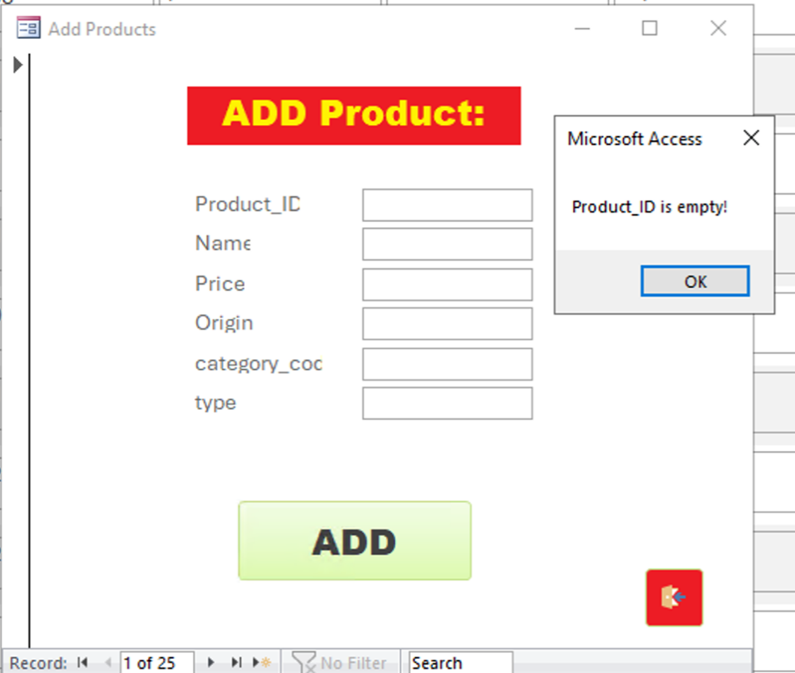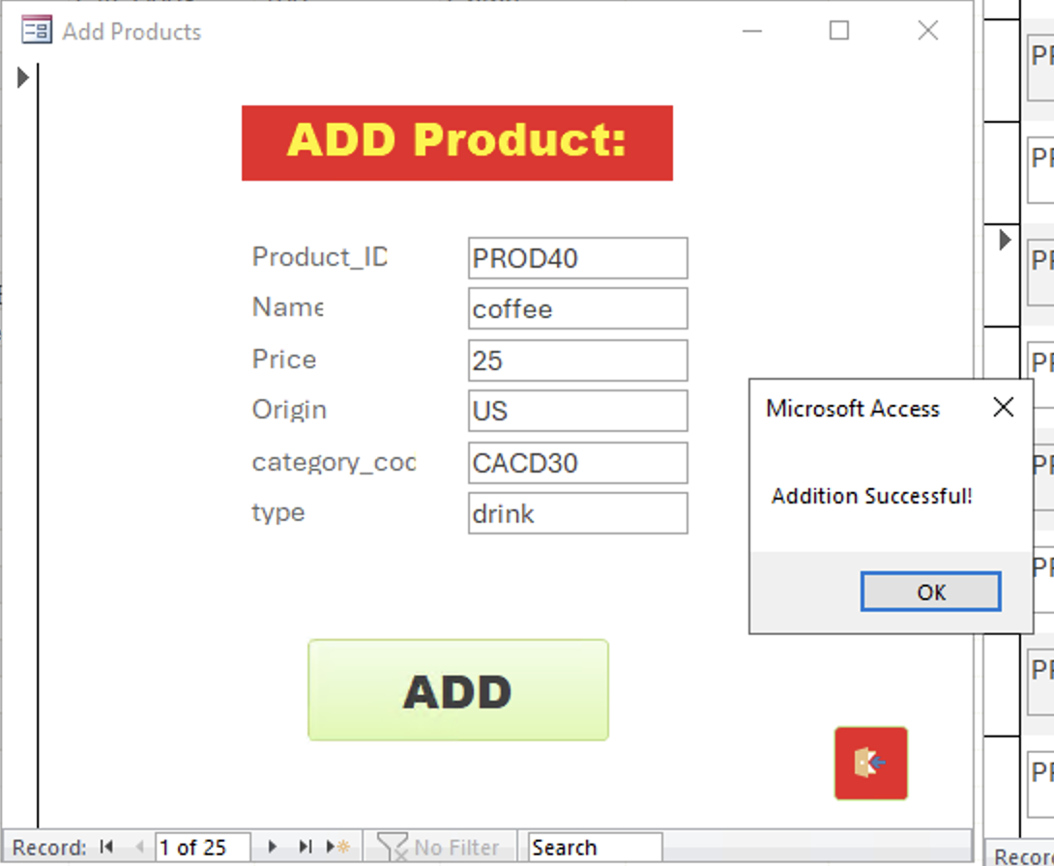

Enter all text box and no repeating data with the table ,and it will show a Msg Addition successful,with repeat data it will show a Msg

Failure.

Empty input will show a MsgBox tell you where is empty.

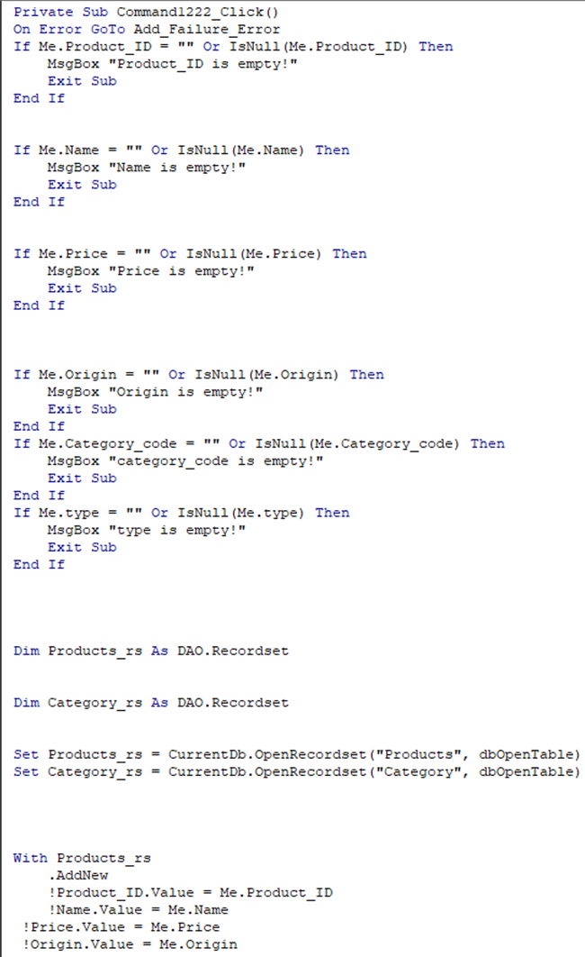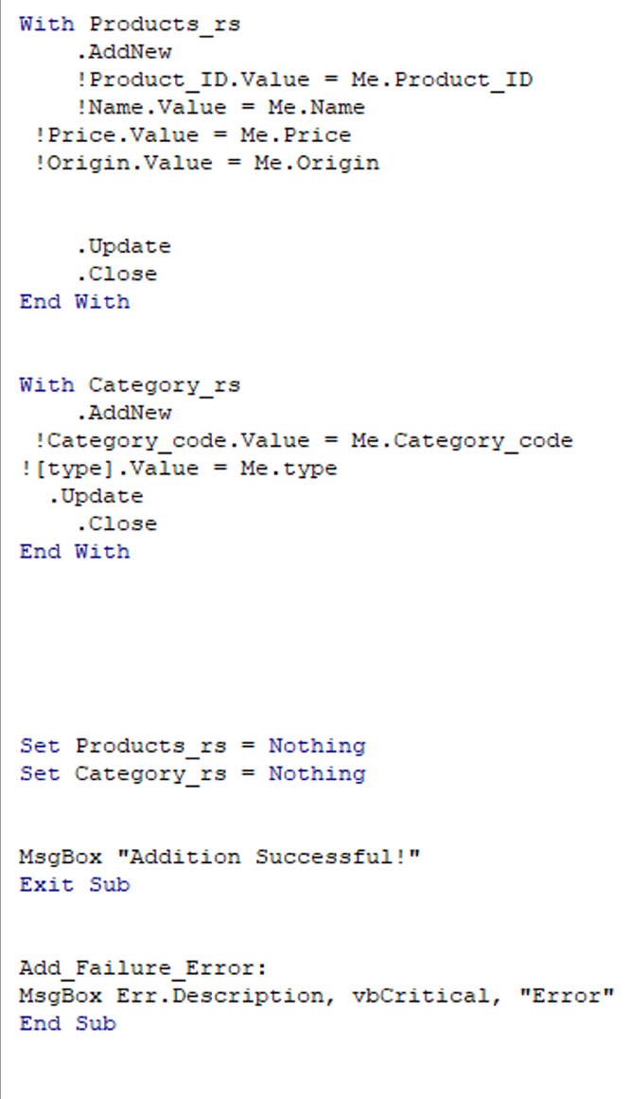

Code check your input data is or not null

Code to conduct change delete and show the Changed status.

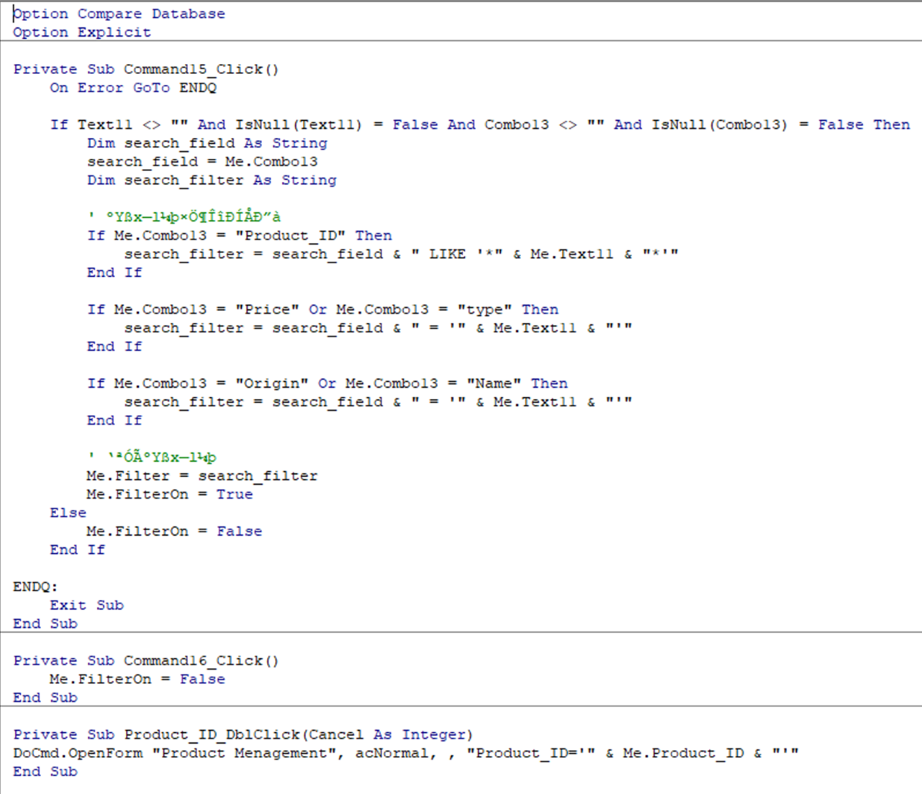

Code can conducting data query.

Code When doubleclick the peoduct ID lt will open a form

Which called product menagemnt

## FROMS: ALL PAYMENTMETHOD



Click the button

Click this button

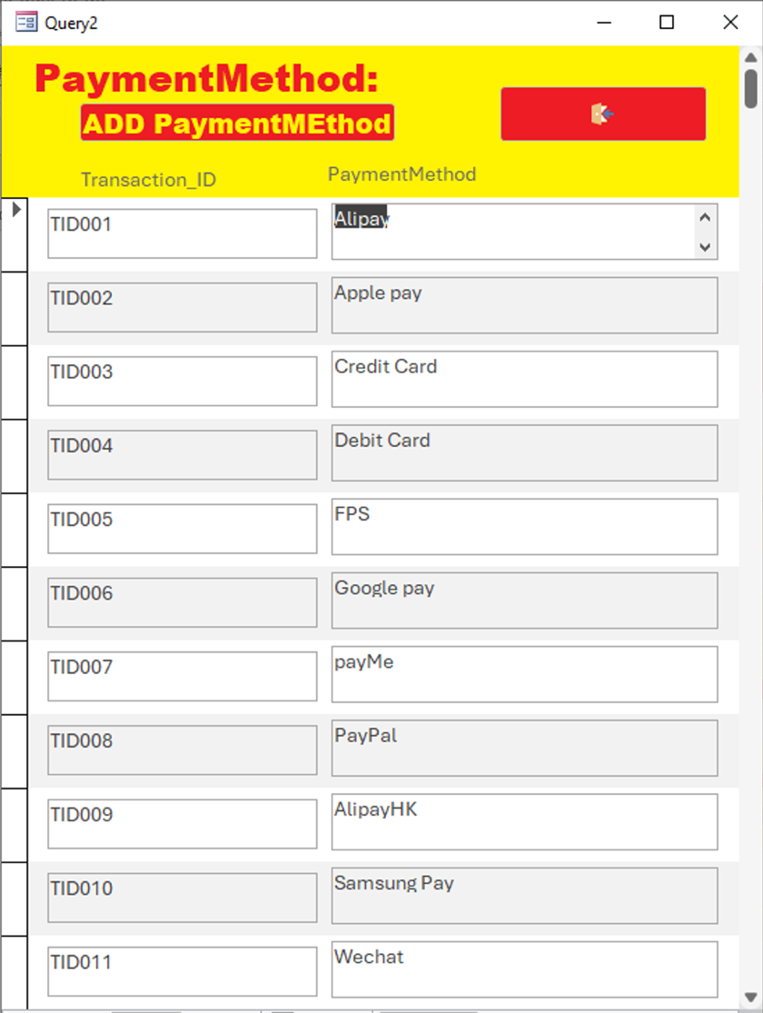

Same function with coustomer

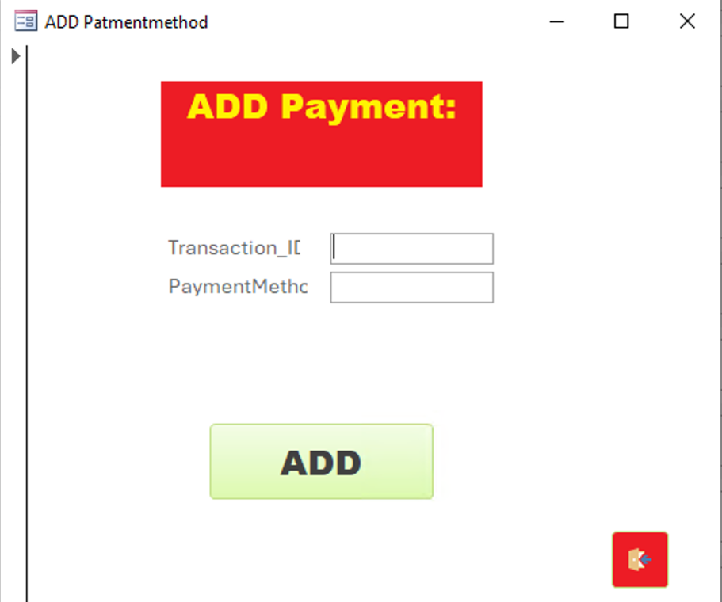

A form for add a new payment method

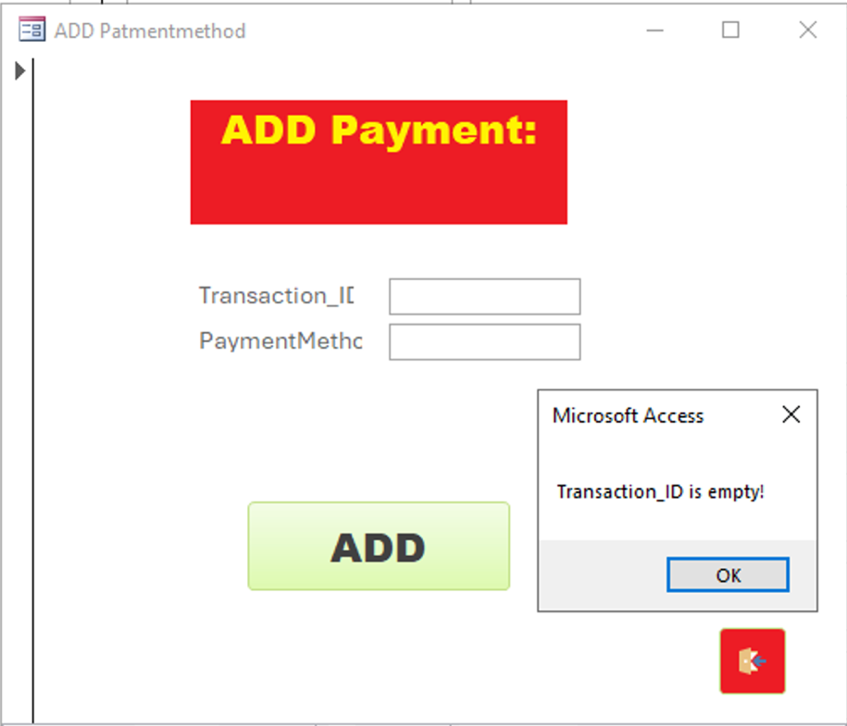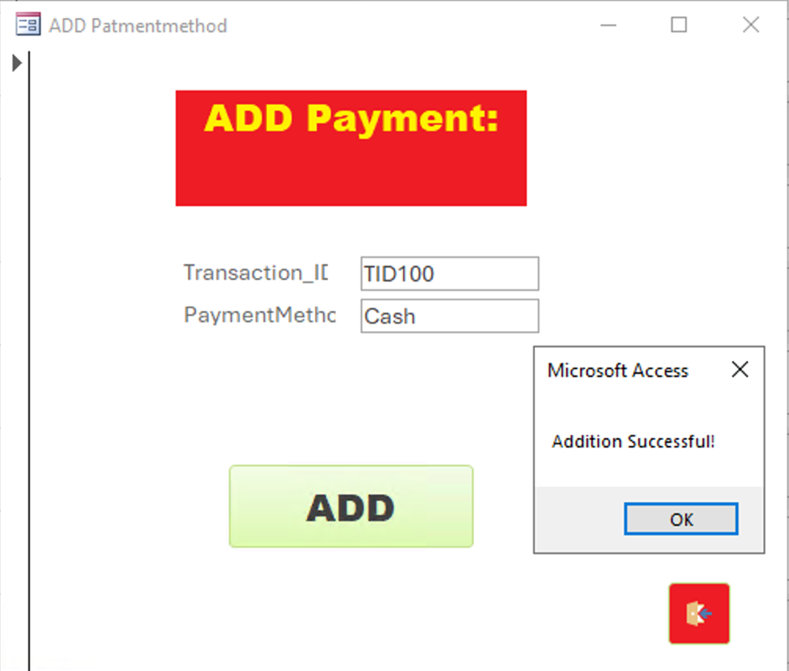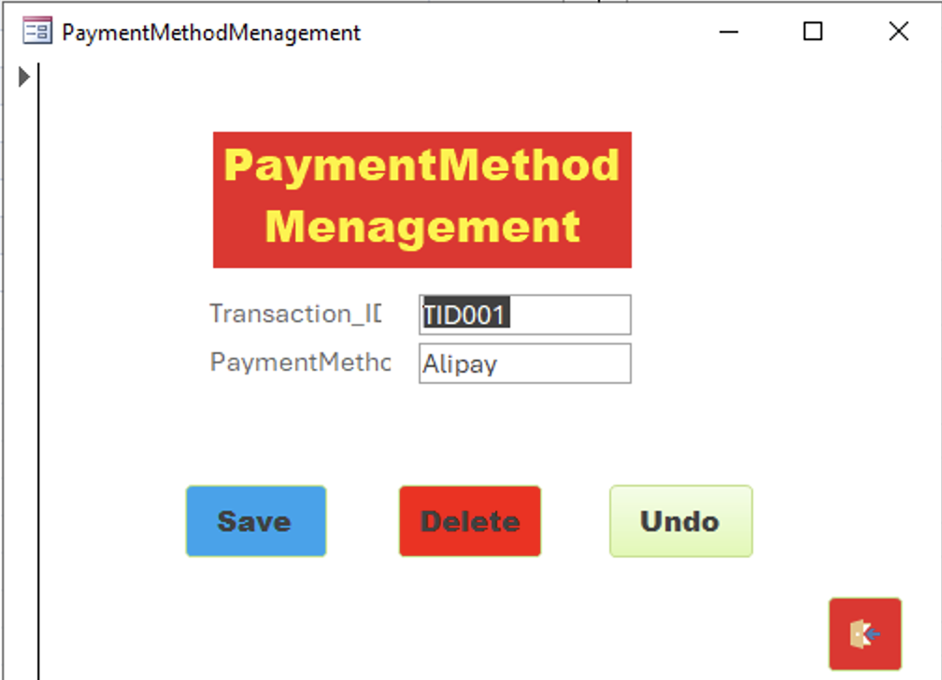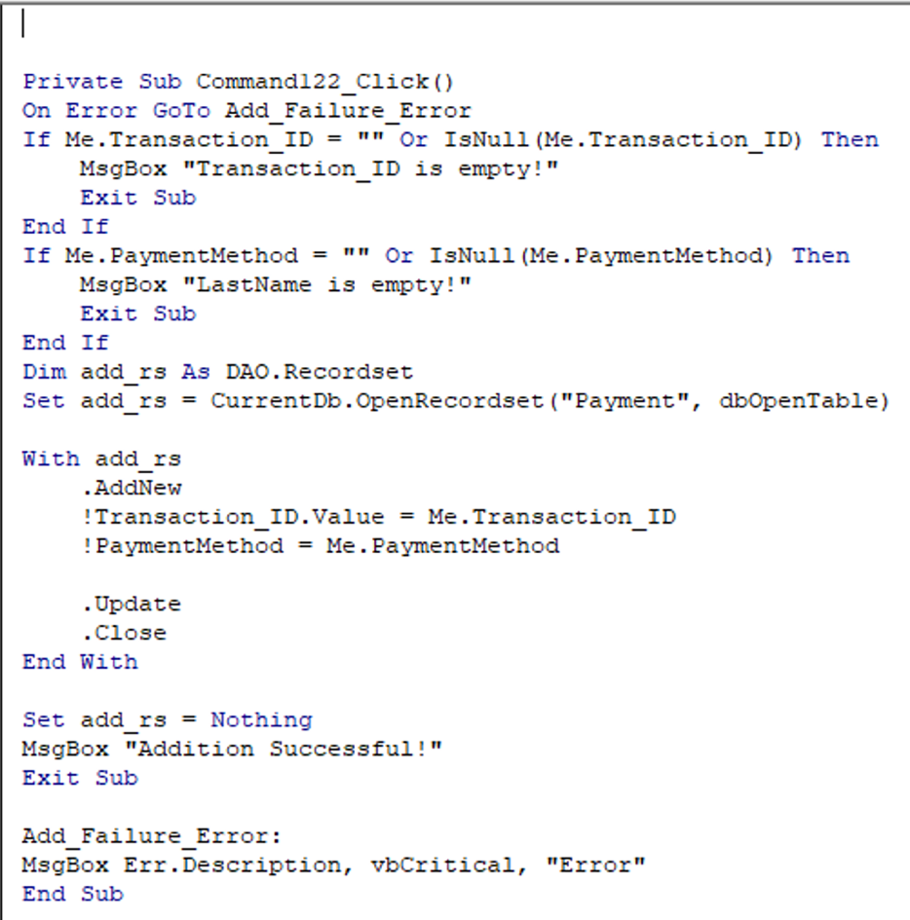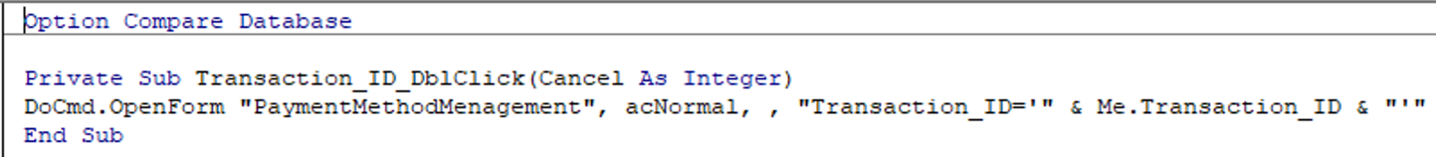

Enter all teat box and no repeating data with table ,and it will show a Msg Addition successful,with repeat data it will show a Msg

Failure.

Empty input will show a MsgBox tell you where is empty.

Enter all text box and no repeating data with the table ,and it will show a Msg Addition successful,with repeat data it will show a Msg

Failure.

Check the is or not null ,your must enter all text box inorder to add the new data

Code when you double click the transatction_id and it will open a new form called patmentmethodmenagement

## FORMS:ORDER RECEIPTS

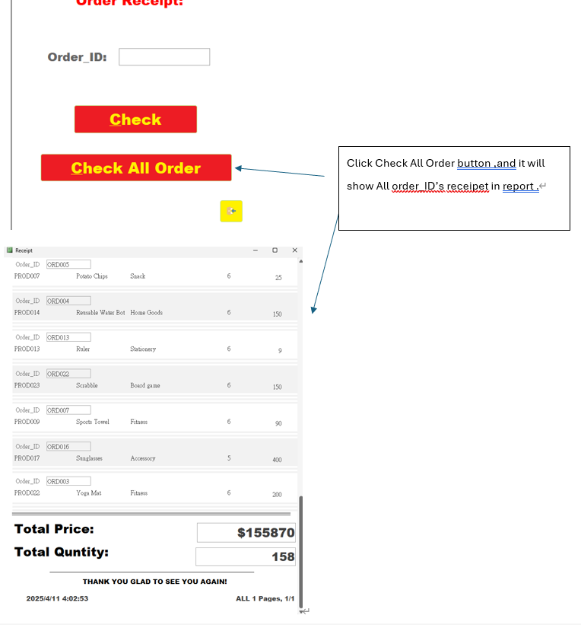

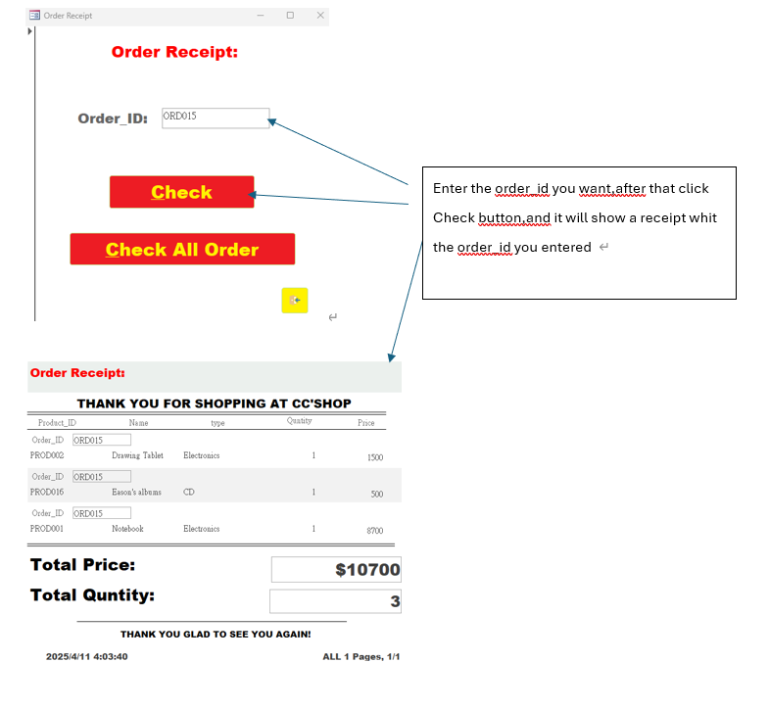

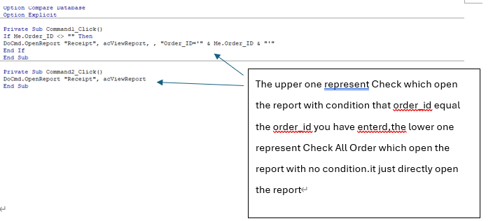

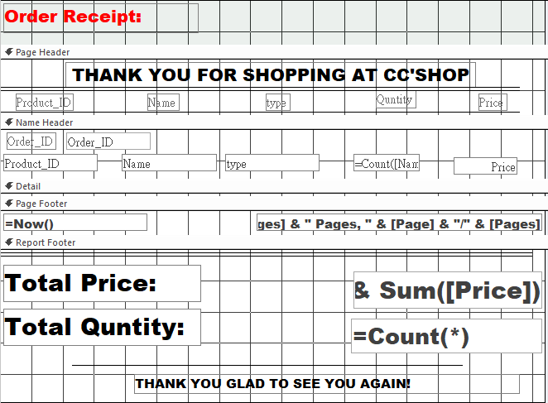

Here shows the design view of report of receipt.

# Implementation details

## Software used:

|  |  |
| --- | --- |
| Software name | Usage |
| MICROSOFT ACCESS | * Build up the database * store the cc store’s data * create the login system and the users interface the though forms function in access * create the queries by writing SQL * create the report though the report function * create the relationship between the table |
| LUCIDCHART | * draw the ERD diagram * draw the relationship of the tables |
| MICROSOFT WORD | * write the report |
| MICROSOFT POWERPOINT | * do the presentation PowerPoint |

## Source of data:

As the CC store is fictional software, we cannot collect the real data in the real world. Therefore, we use AI to help us generate some fake data.

# Difficulties

## Design phase:

It is hard to clearly Identify the relationship of each table

As we are beginners, we have some ideas in mind. We find it is hard to present it in the Access.

Implementation phase:

There is a plenty of Access’s functions did not learn in the class. Therefore We acting as a begginner waste most of time to learn how to use it.

When we create a lot of SQLS and we find some data problems, it is hard to make a change. If we do so, all sql can not work anymore.

## Lessons learnt

It is hard to clearly Identify the relationship of each table

# **Work distribution list**

|  |  |  |  |
| --- | --- | --- | --- |
| Task Name | Start Date | Finish Date | Responsible |
| Access Forms | 6/4 | 9/4 | LIN Rui Peng |
| Access Report | 9/4 | 10/4 | LIN Rui Peng |
| Access queries | 6/4 | 10/4 | SHUM Yu Ching |
| Access queries | 6/4 | 10/4 | LU Chun Hei |
| Word | 3/4 | 10/4 | TING Ho Man, CHEN Wei Yui, SHUM Yu Ching, LIN Rui Peng, LU Chun Hei |
| PPT | 6/4 | 10/4 | TING Ho Man, CHEN Wei Yui, SHUM Yu Ching |

# Conclusion

The database management system currently developed can meet the needs of enterprises to query, change and add data, can query inventory quantities.

Providing two interfaces for different users, Maintainer and Enterpriser. Only the view of maintainer can perform corresponding functional operations, Enterpriser can view the data only. This design ensures efficient data management while maintaining security and control.

# **Reference**

1. Computer Learning Zone. (2023, May 4). *How to add simple User-Level Security to Microsoft Access Databases* [Video]. YouTube. https://www.youtube.com/watch?v=Z-t5ltS85n4

2. 凌霄百科. (n.d.-c). *%E3%80%90%E4%BB%93%E5%BA%93%E7%AE%A1%E7%90%86%E7%B3%BB%E7%BB%9F%E3%80%91access%E6%95%B0%E6%8D%AE%E5%BA%93%E8%AE%BE%E8%AE%A1%E6%8A%A5%E5%91%8A%20%E6%95%B0%E6%8D%AE%E5%BA%93%E5%88%B6%E4%BD%9C%E5%85%A8%E8%BF%87%E7%A8%8B%E5%BD%95%E5%88%B6%E8%AE%B2%E8%A7%A3%20acces%E6%95%B0%E6%8D%AE%E5%BA%93%E5%AE%9E%E4%BE%8B%20VBA%E7%BC%96%E7%A8%8B%20%E6%95%B0%E6%8D%AE%E5%BA%93%E7%B3%BB%E7%BB%9F%E8%AE%BE%E8%AE%A1* [Video]. https://www.bilibili.com/video/BV1df4y1v7db?spm_id_from=333.788.videopod.episodes&vd_source=b1bf283a934e3c0f2708d8a1db679d69&p=8